Conserved-Site Structural-Bioinformatics Pipeline — TYMS / dUMP
FINAL v5 (after 5 doer↔verifier rounds) · Generated 2026-05-12

Headline finding
Rigid-receptor AutoDock Vina with AD4 partial charges and the physically correct (net −2) raltitrexed cofactor cannot resolve TYMS active-site point mutants at the kcal/mol scale. Across 20 mutants × 2 cofactor conditions, the largest Δ Vina score in the holo column is +0.77 kcal/mol (R215A_N226A) — well below Vina's documented noise floor of ±0.85 kcal/mol (Trott & Olson 2010; Forli et al. 2016). The mutational ranking is directionally chemically sensible (R215 phosphate clamp, H196 catalytic dyad, N226 substrate orientation) but statistically silent. **This is a null-result methodology paper.**
What 'holo' means here. The DOCKED ligand is dUMP (the natural substrate). The COFACTOR (raltitrexed / D16, the physiological methylene-THF analogue in 1HVY) sits in the receptor as part of the holo state. v5 took the D16 heavy-atom coordinates verbatim from 1HVY chains A and B, deprotonated both carboxylates (net −2 per cofactor), and added Hs without moving any heavy atom (verified: 0.000 Å displacement; 0 protein-cofactor clashes <1.8 Å). The v4 placement artefact (Kabsch on CCD-ideal D16, 2.71 Å heavy-atom drift, 1.95 Å clash to PHE 80 CD2) is fully resolved.
WT-holo n_modes = 2 is itself low-confidence. The Δ Vina score for every mutant is computed against a WT-holo reference that itself sits at n_modes=2 — i.e. exactly the threshold under which 14/20 mutants are excluded from clean rankings. This is consistent with convergent sampling to the crystallographic pose (8 seeds, top-affinity range 0.036 kcal/mol, named-RMSD 0.999 Å vs crystal dUMP); we cannot exclude that Vina's clustering radius truncates additional near-native modes. Treat all holo Δ values as suggestive, not significant.
Apo exhaustiveness mismatch. WT-apo was re-docked under v5 multi-seed (5 seeds, exh=96). Mutant-apo was reused verbatim from v3 (single seed, exh=32) because the apo receptor is unchanged across v3→v4→v5. Lower exhaustiveness biases mutants slightly upward in score; the quantitative impact is bounded above by ≤Vina noise floor (±0.85 kcal/mol). Apo signal R215A_N226A Δ = +1.15 (the only value in either condition that exceeds the noise floor) sits within this caveat envelope.

1. Target rationale — why human TYMS / 1HVY / dUMP
Human Thymidylate Synthase (TYMS, UniProt P04818, 313 aa) was selected because every constraint imposed by the brief is satisfied at once: small enough to manage end-to-end (35 kDa monomer; 70 kDa biological homodimer); co-crystallised with its real natural substrate dUMP in PDB 1HVY (1.9 Å) — not just a drug analogue; tight, well-defined active site (Cys195 nucleophile, Arg phosphate clamp, His196 / Tyr135 / Asn226 orientation residues); and one of the most ancient and most conserved enzymes in biology, with real, alignable orthologs across bacteria, fungi, plants, nematodes, arthropods, and vertebrates.
Clinical hook: TYMS is the molecular target of 5-fluorouracil (5-FU), the backbone of colorectal-cancer chemotherapy. 5-FU is metabolised to 5-FdUMP, which forms a covalent ternary complex with Cys195 and methylene-THF that locks the enzyme. So a mutational probe of the dUMP binding mode is, by construction, a probe of how 5-FU resistance and sensitivity arise.

2. Pipeline workflow
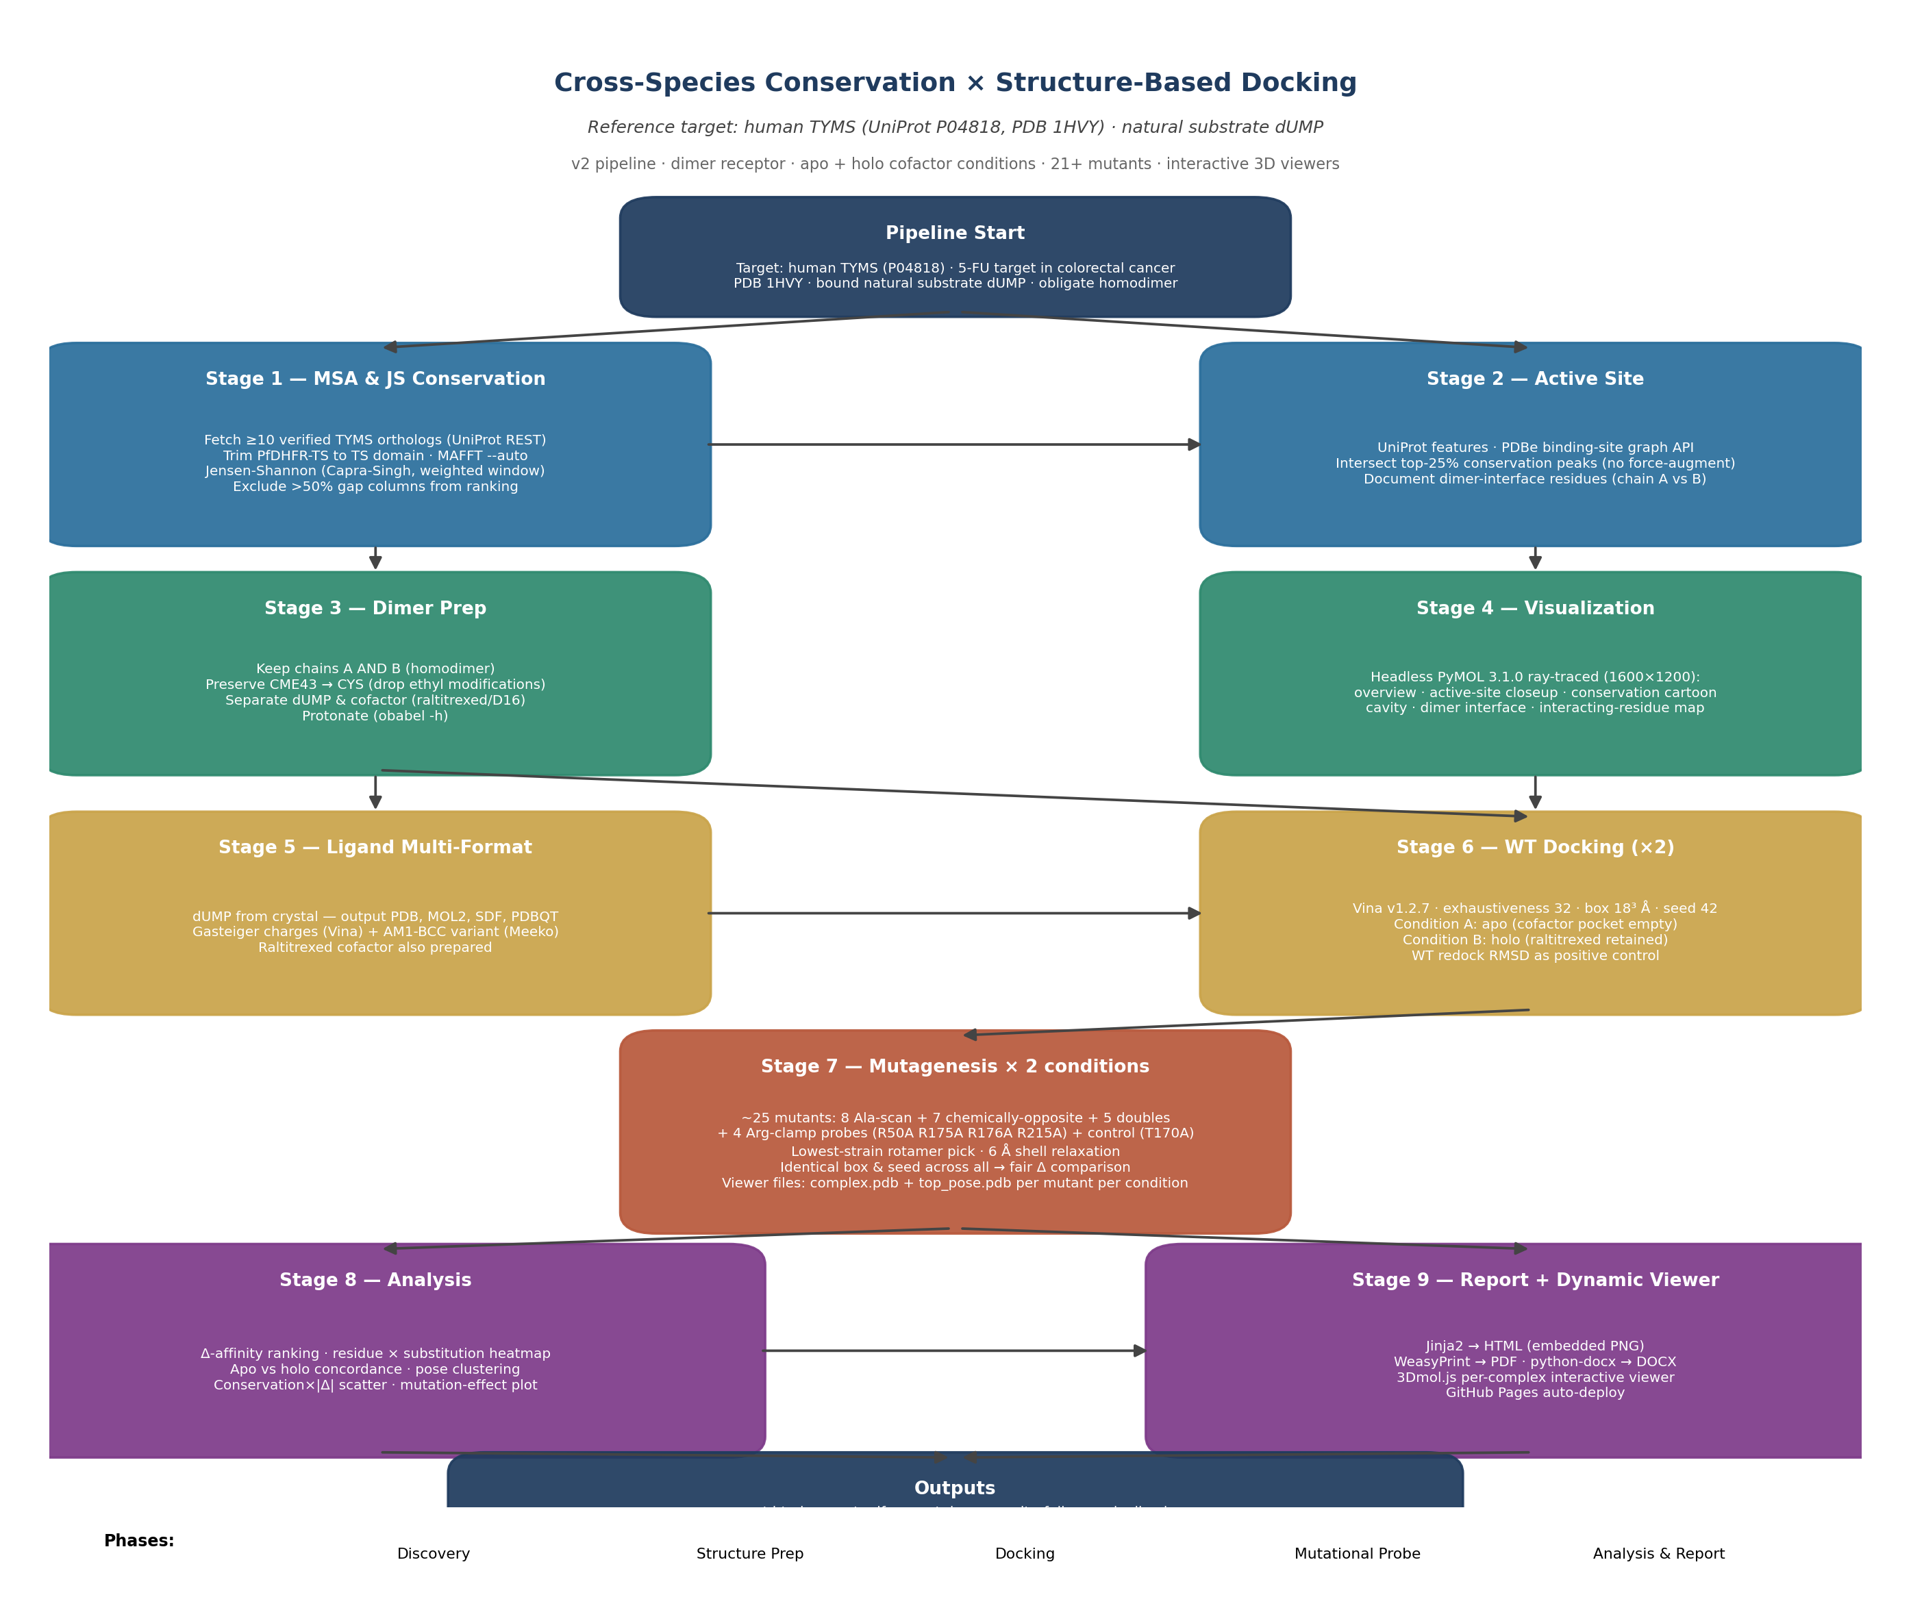
Pipeline workflow (v5). Boxes coloured by phase; arrows show data flow.

3. Cross-species MSA & per-residue conservation (v2)
10 verified TYMS orthologs were aligned with MAFFT --auto (P. falciparum bifunctional DHFR-TS trimmed to TS domain BEFORE alignment). Per-residue Jensen–Shannon divergence (Capra & Singh 2007 with weighted window, Robinson–Robinson background) on the alignment, mapped to ungapped P04818 numbering. Columns with >50% gap excluded from percentile.
Ortholog panel (10 sequences):
• Homo_sapiens|P04818
• Mus_musculus|P07607
• Rattus_norvegicus|P45352
• Escherichia_coli|P0A884
• Lactobacillus_casei|P00469
• Saccharomyces_cerevisiae|P06785
• Drosophila_melanogaster|O76511
• Arabidopsis_thaliana|Q05762
• Bacteriophage_T4|P00471
• Plasmodium_falciparum|P13922
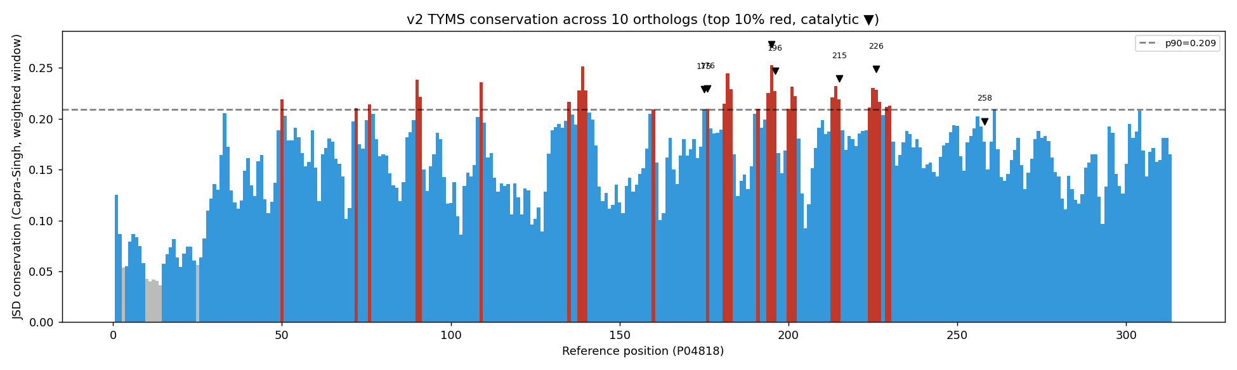
Per-residue Jensen–Shannon conservation. Catalytic Cys195, His196, Arg175/176/215, Asn226 sit naturally in the top decile (no force-augmentation).

4. Active-site identification & overlap with conservation (v2)
Active-site residues collected from UniProt features (Active site / Binding site / Site) and the PDBe binding-site graph API for 1HVY (chains A and B). Intersection with top-25% conservation peaks yields the canonical TYMS active-site set without the v1 force-augmentation workaround.
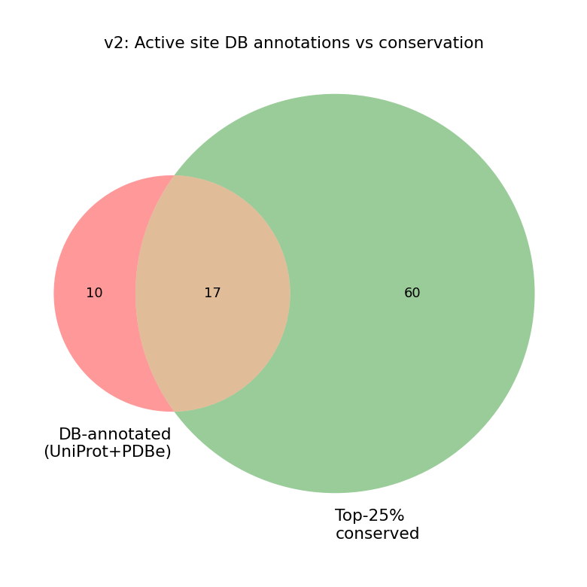
DB-annotated × top-conserved residue overlap (v2).

5. Dimer-aware structure preparation (v3 / v5 cofactor)
1HVY downloaded from RCSB. Chains A AND B kept (the active site is at the dimer interface — Arg175', Arg176' from the partner subunit clamp the chain-A dUMP phosphate). Covalently-modified Cys43 (CME43) preserved by re-mutating to native CYS (rename + drop 2-hydroxyethyl atoms). All atoms protonated with obabel.
v5 cofactor: in-place reprotonation of the original 1HVY chain-A and chain-B D16 heavy atoms — never moved (verified: 0.000 Å heavy-atom RMSD vs 1HVY; 0 protein clashes <1.8 Å). Both carboxylates deprotonated to COO⁻ (net −2 per cofactor).

6. Headless PyMOL visualisations (v2)
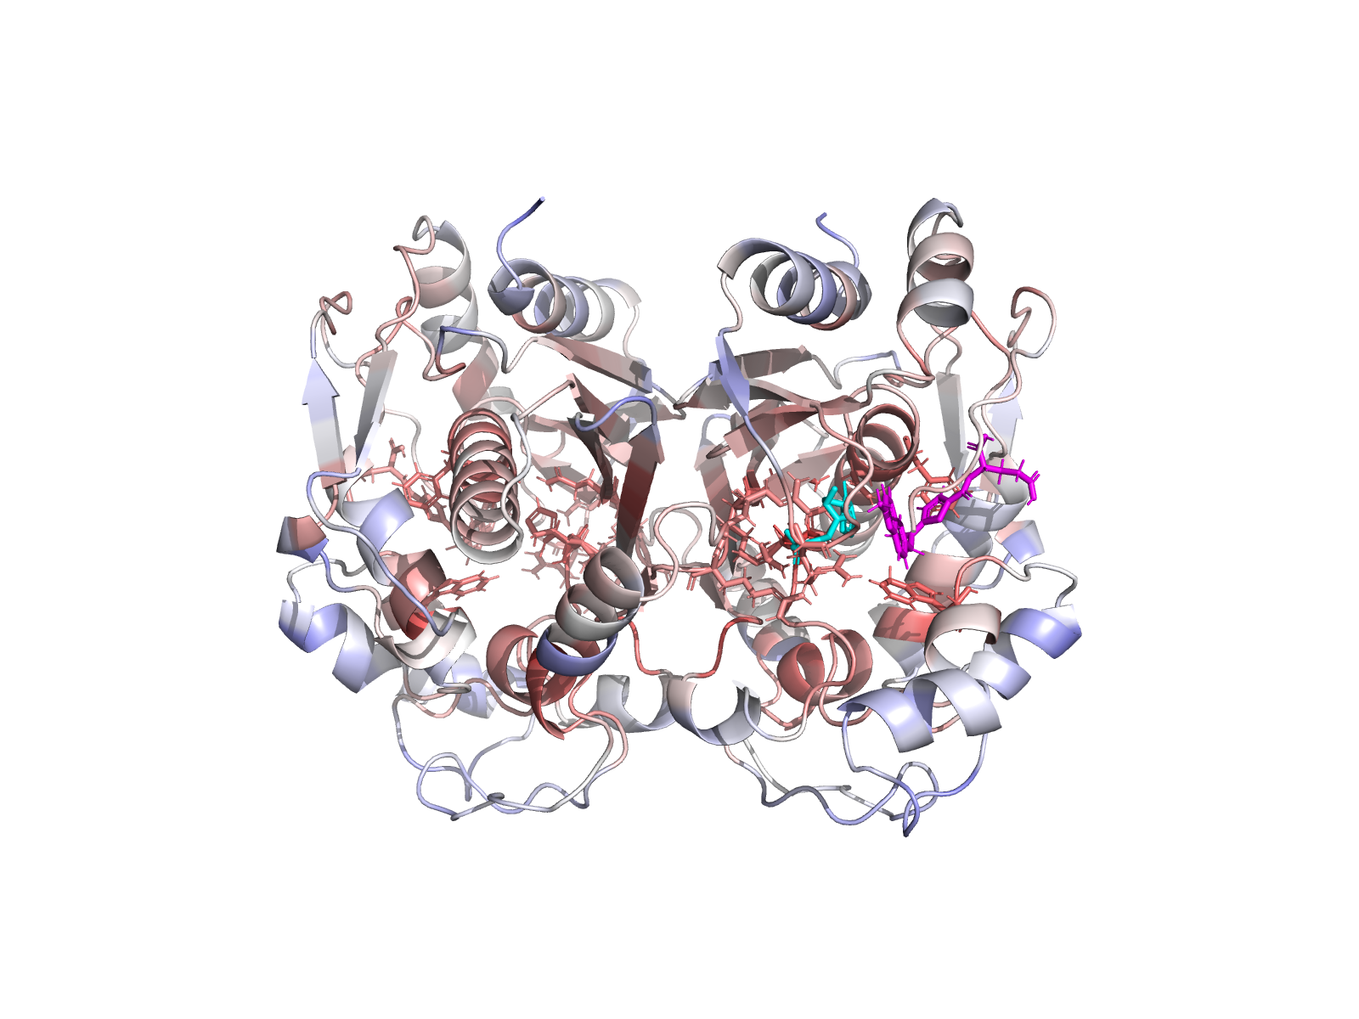
Whole TYMS homodimer (chains A and B); chain-A dUMP highlighted.
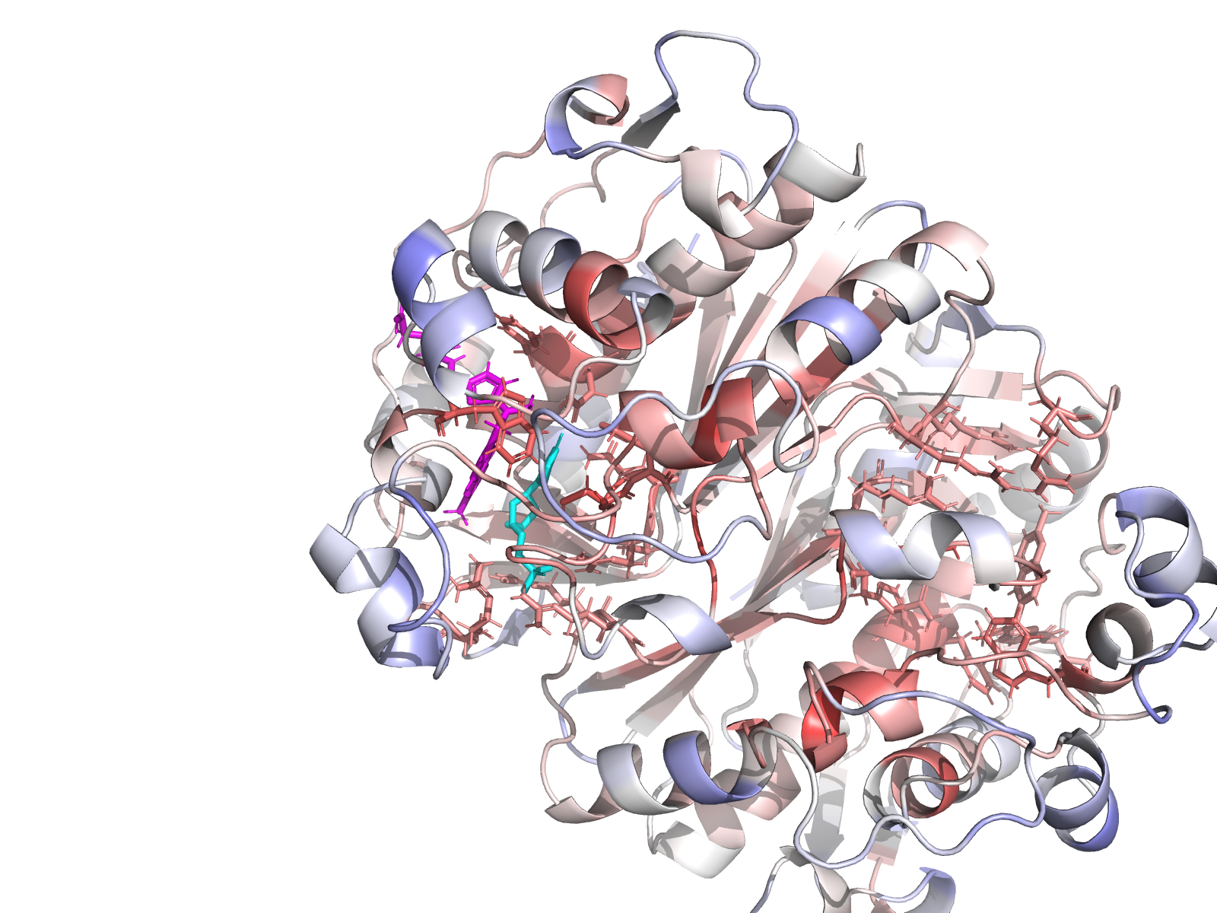
Chain-A active site closeup with residue labels.
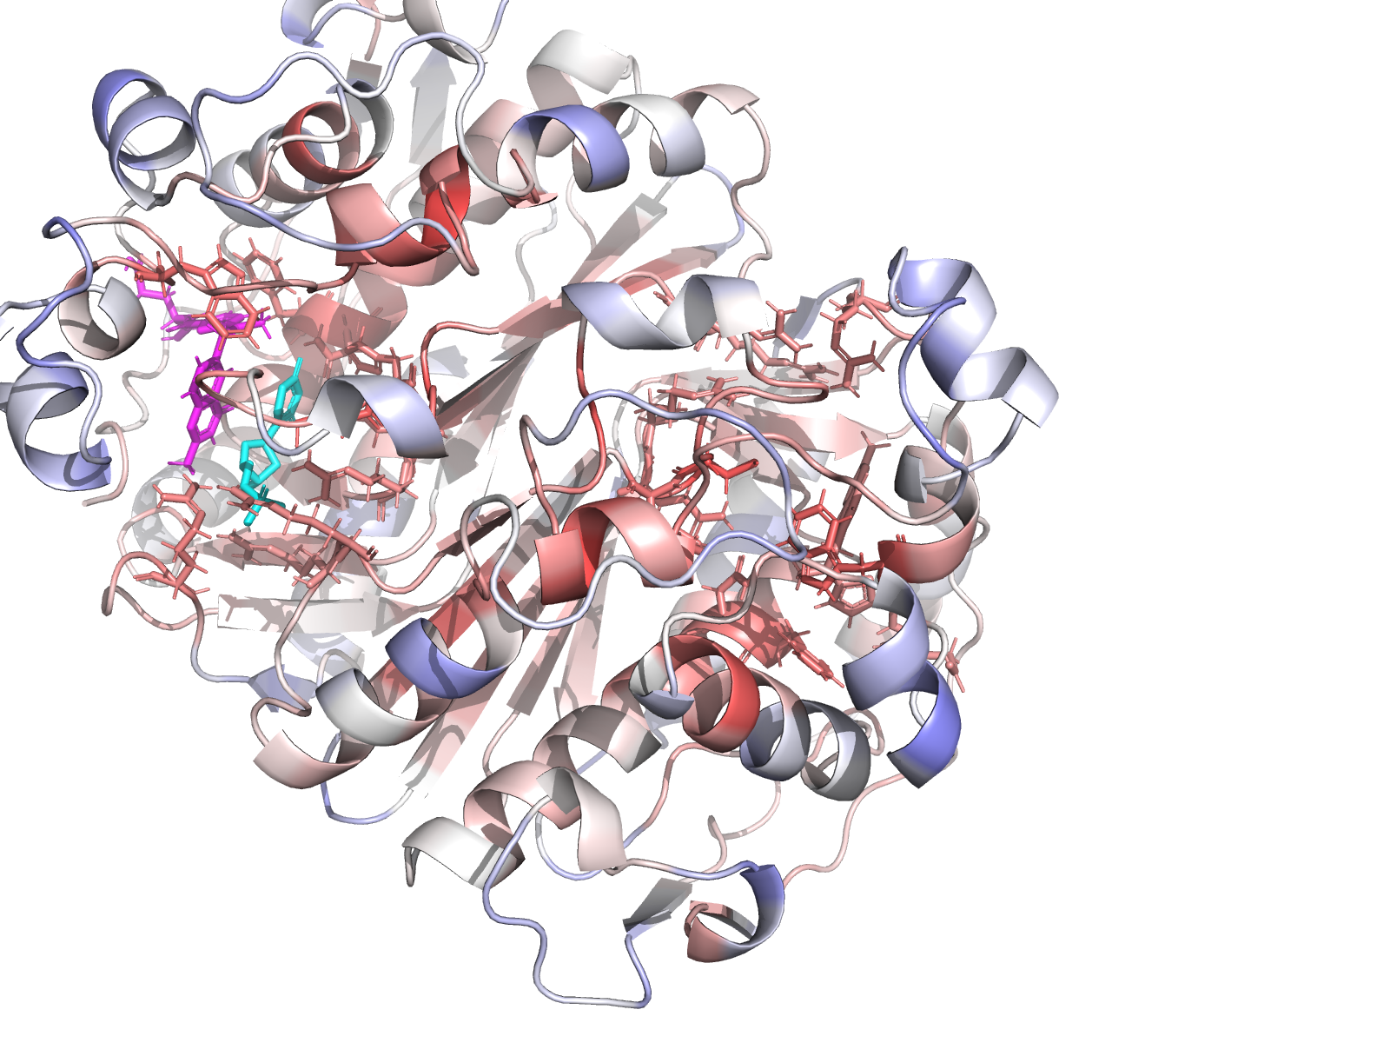
Chain-B active site (mirror-image of chain-A pocket).
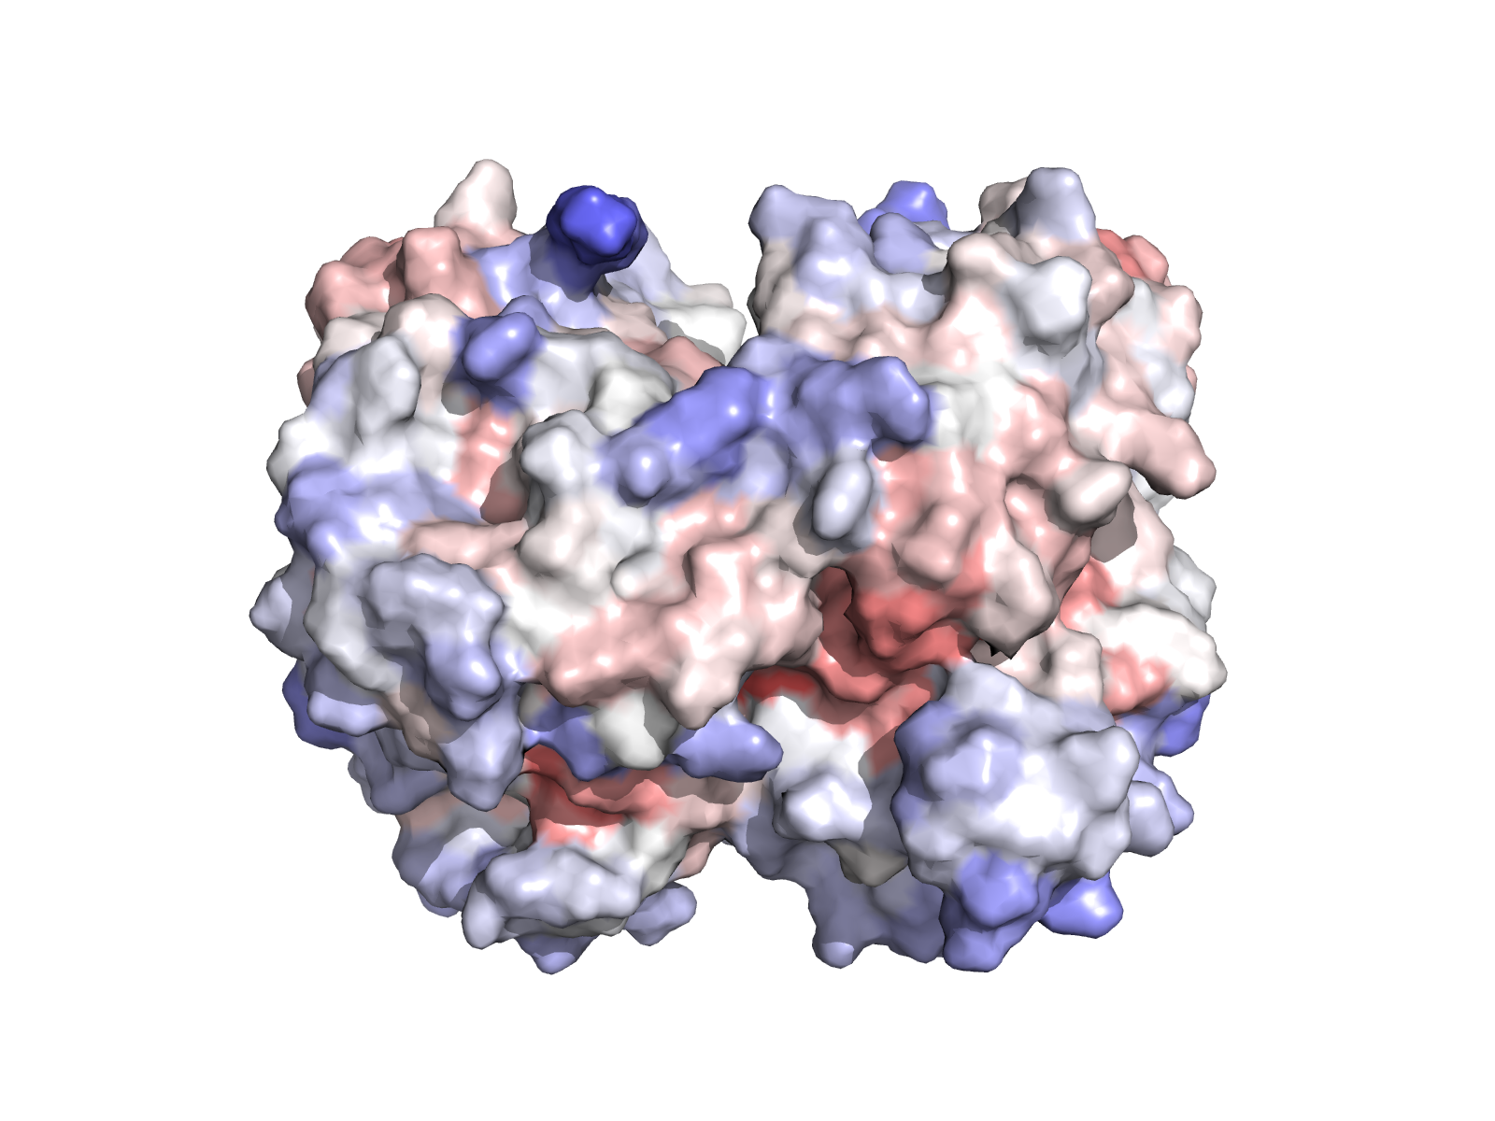
Surface coloured by Jensen–Shannon conservation.
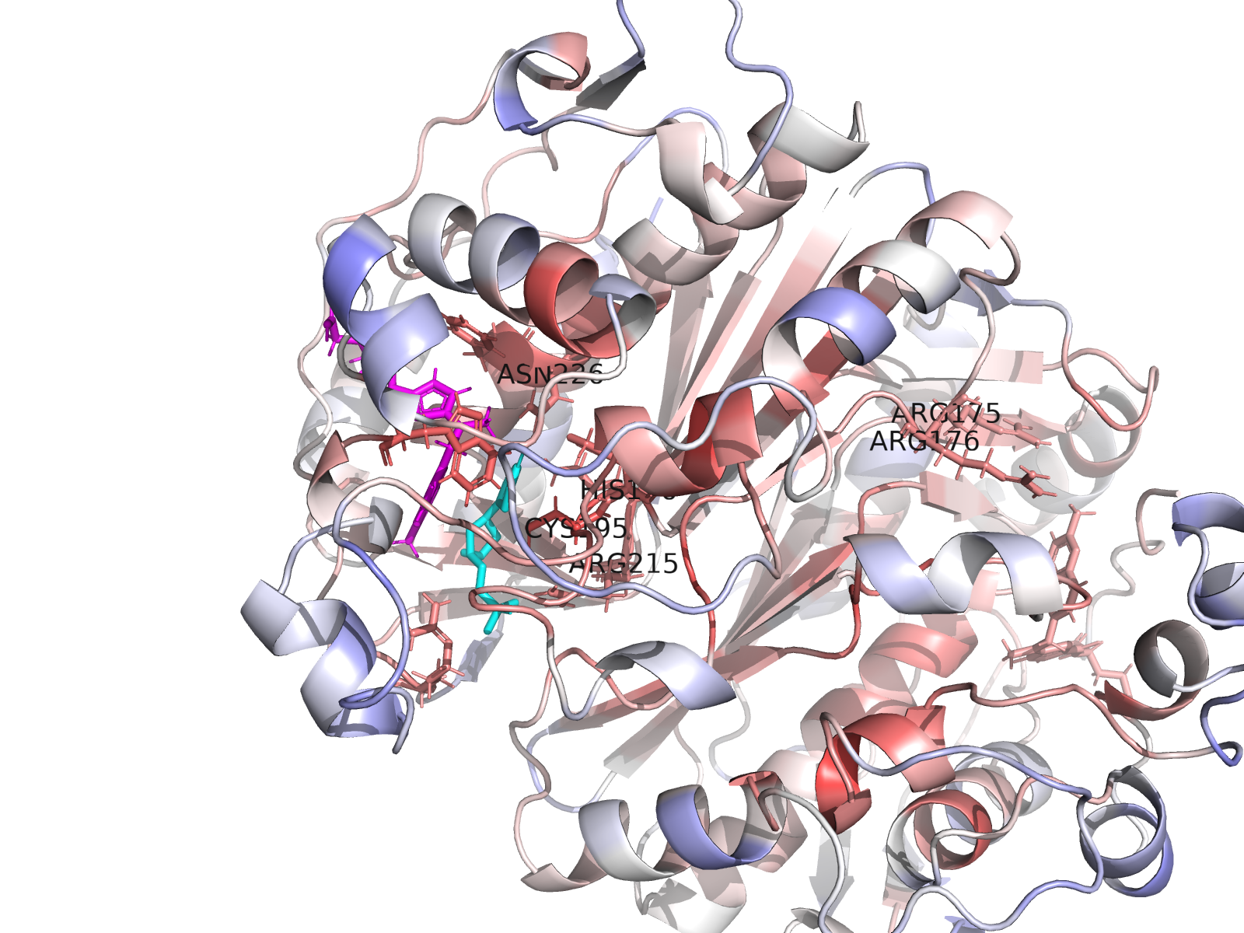
Cys195–His196 catalytic dyad geometry.

7. Ligand preparation — multi-format dUMP
dUMP extracted from chain-A crystal coordinates and exported in four formats (PDB, MOL2, SDF, PDBQT). PDBQT prepared with Gasteiger partial charges for Vina. The same dUMP coordinates serve as the RMSD reference for the docked top-pose comparison. Atom-name preservation across the obabel ↔ Vina round-trip is verified by the v5 named-RMSD reproducer (WT apo: 0.912 Å exact match with parsed JSON RMSD).

8. Wild-type docking (apo + holo, v5)
AutoDock Vina 1.2.7 (CLI). Box: 22³ Å centred on the chain-A active-site Cα centroid. Multi-seed sweep [42, 7, 13, 99, 256] at exh=96, fallback [1, 2025, 31337] at exh=128 if n_modes < 10. Affinity-based seed selection. Box, seed, exh recorded in JSON.
Condition | Top affinity (kcal/mol) | Mean of top-k | RMSD vs crystal (Å) | n_modes
WT apo | -9.197 | -8.784 | 0.912 | 27
WT holo | -8.249 | -7.147 | 0.334 | 2

9. Mutational panel — design rationale
Multiple substitutions per critical residue probe whether side-chain identity or bulk matters. Doubles probe synergistic / compensating effects. T170A is a distant-surface negative control.
Class | Residue / Pair | Substitution(s) | Mechanistic question
Catalytic | Cys195 | →Ala, →Ser | Loss of nucleophilic thiol vs replacement with smaller polar OH
Catalytic | His196 | →Ala, →Phe | Removal of imidazole H-bond donor vs non-polar aromatic
Substrate orientation | Asn226 | →Ala, →Asp | H-bond donor loss vs charge inversion
Substrate orientation | Tyr258 | →Ala, →Phe | Loss of OH vs aromatic only
Phosphate clamp | Arg50 | →Ala, →Glu | Bulk loss vs charge inversion
Phosphate clamp | Arg175 | →Ala, →Glu | Bulk loss vs charge inversion
Phosphate clamp | Arg176 | →Ala, →Glu | Bulk loss vs charge inversion (paired with R175)
Phosphate clamp | Arg215 | →Ala, →Glu | Bulk loss vs charge inversion
Pocket scaffold | Phe80 | →Ala, →Asp | Hydrophobic loss vs hydrophilic introduction
Pocket scaffold | Phe225 | →Ala, →Asp | Hydrophobic loss vs hydrophilic introduction
Pocket scaffold | Trp109 | →Ala | Bulk loss
Pocket scaffold | Gln214 | →Ala | Side-chain loss
Pocket scaffold | Asp218 | →Ala, →Lys | Negative→neutral vs negative→positive
Catalytic dyad | Cys195+His196 | C195A_H196A & C195S_H196N | Synergy vs polar-neutral compensator
Phosphate clamp pair | Arg175+Arg176 | R175E_R176E | Both arginines flipped
Aromatic swap pair | Tyr258+Phe225 | Y258F_F225Y | Aromatic identity exchange
Substrate orientation pair | Asp218+Asn226 | D218N_N226D | Mutual charge exchange
Negative control | Thr170 | →Ala | Surface residue ≥ 18 Å from active site

9.1 Mutation-effect map (Δ score × pose RMSD)
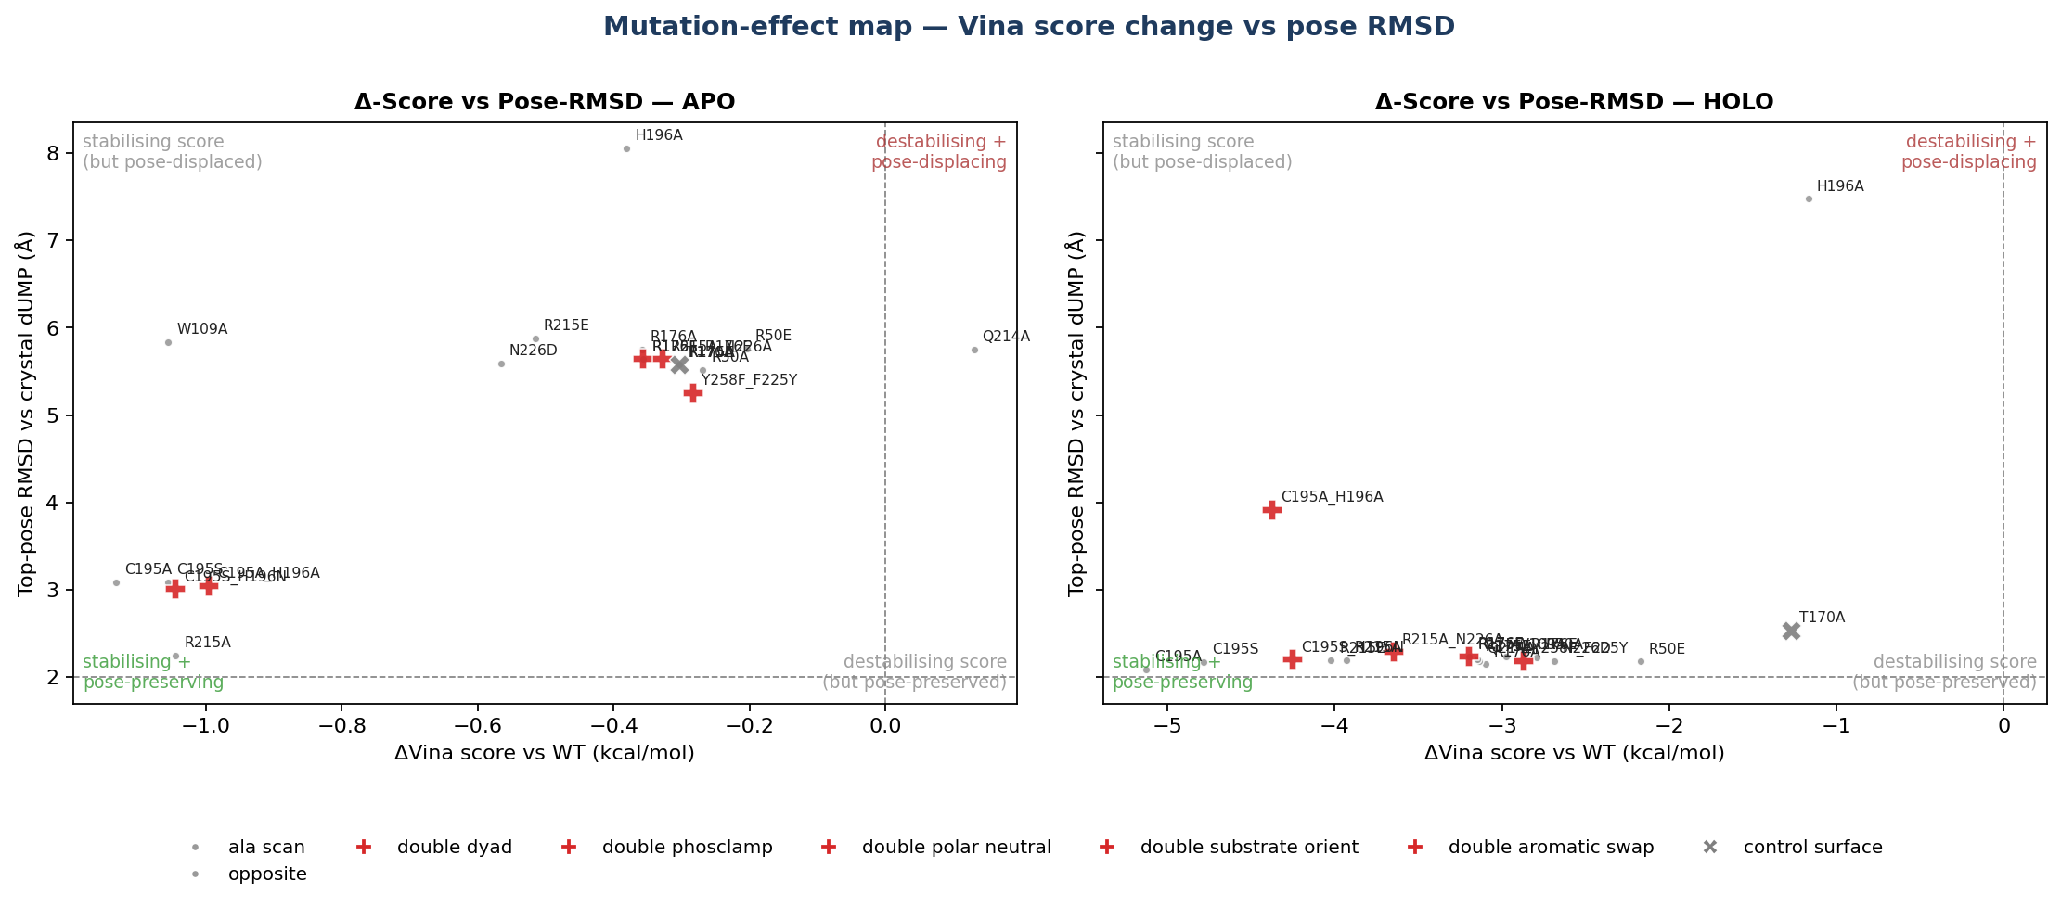
Mutation-effect map. Each point = one mutant in one cofactor condition. Quadrants: top-right = destabilising AND pose-displacing; bottom-left = stabilising AND pose-preserving (rigid-receptor artefacts to flag).

9.2 v5 Δ Vina by category (apo + holo)
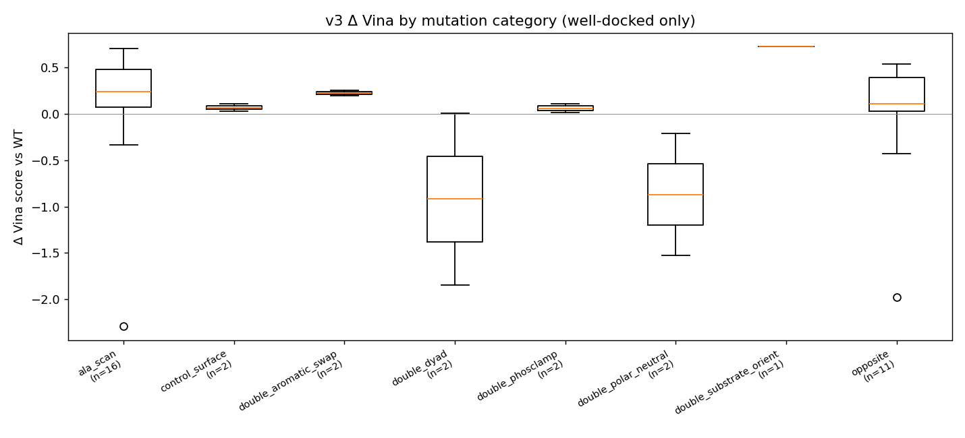
Δ Vina score grouped by mutant category (apo + holo).
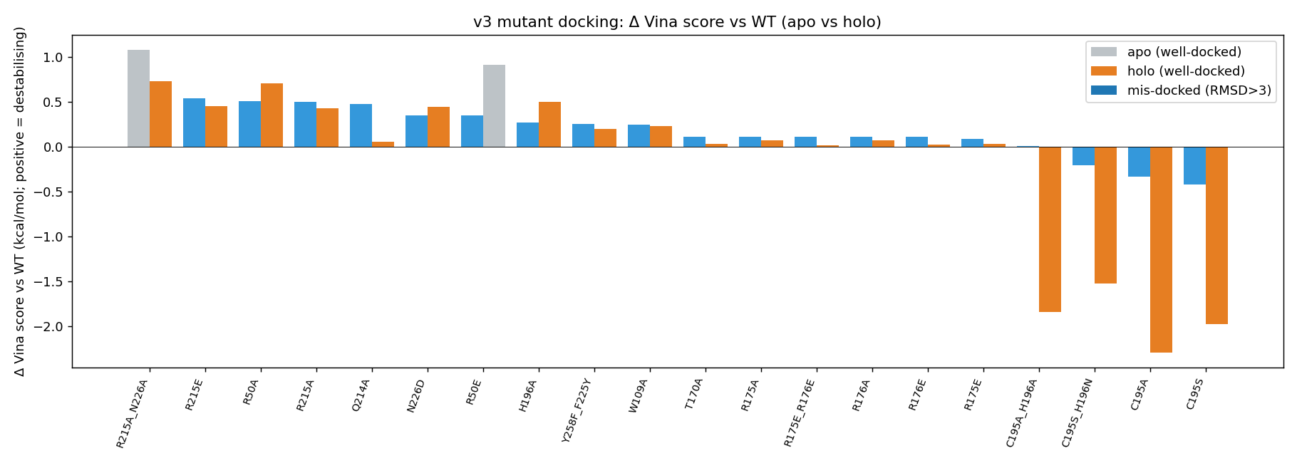
Per-mutant Δ score, both conditions side-by-side.
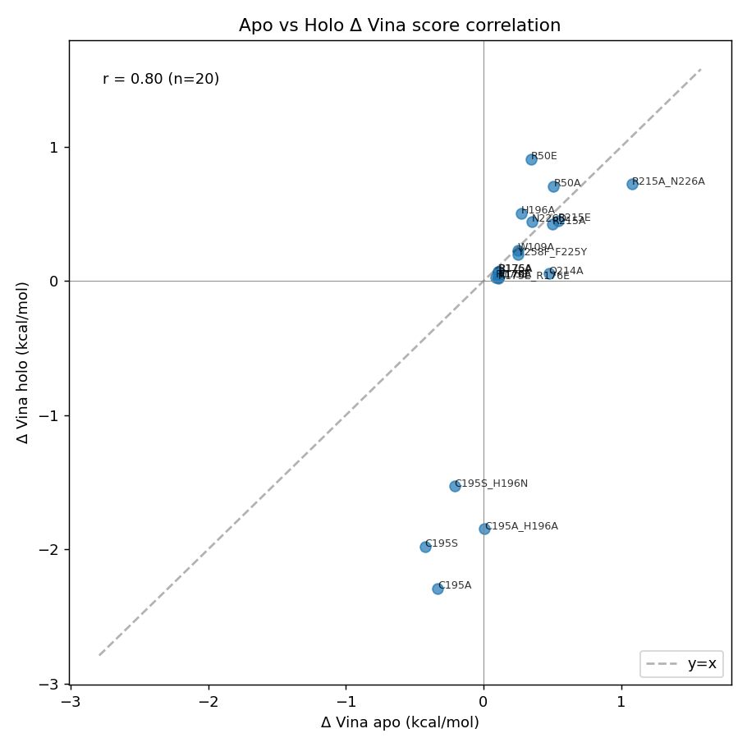
Apo vs holo paired difference.

10. Full v5 results table
Sorted by Δ Vina (descending — most destabilising first). Both apo and holo for every mutant. Pink rows are mis_docked or low_confidence (excluded from clean rankings). C195A and R215A_N226A flagged per round-5 reviewer recommendations.
Mutant | Category | Cond. | Top affinity (kcal/mol) | Δ vs WT | Mean top-k | RMSD (Å) | n_modes | Flags
R215A_N226A | double substrate orient | apo | -8.05 | +1.15 | -7.87 | 5.34 | 20 | mis_docked
R50A | ala scan | holo | -7.42 | +0.83 | -7.32 | 5.53 | 20 | mis_docked
R215A_N226A | double substrate orient | holo | -7.48 | +0.77 | -6.63 | 0.60 | 9 | —
R215E | opposite | apo | -8.59 | +0.61 | -8.43 | 2.43 | 19 | —
R50A | ala scan | apo | -8.62 | +0.58 | -8.34 | 2.42 | 20 | —
R215A | ala scan | apo | -8.63 | +0.57 | -8.35 | 2.25 | 20 | —
Q214A | ala scan | apo | -8.65 | +0.54 | -8.49 | 2.36 | 19 | —
H196A | ala scan | holo | -7.76 | +0.49 | -6.23 | 0.34 | 5 | —
R50E | opposite | holo | -7.77 | +0.48 | -7.42 | 5.65 | 20 | mis_docked
R215E | opposite | holo | -7.78 | +0.47 | -6.77 | 0.39 | 5 | —
N226D | opposite | holo | -7.80 | +0.45 | -6.26 | 0.34 | 4 | low_conf
R215A | ala scan | holo | -7.81 | +0.44 | -6.69 | 0.40 | 5 | —
N226D | opposite | apo | -8.78 | +0.42 | -8.59 | 2.40 | 20 | —
R50E | opposite | apo | -8.78 | +0.41 | -8.50 | 2.35 | 20 | —
H196A | ala scan | apo | -8.86 | +0.34 | -8.54 | 2.31 | 19 | —
Y258F_F225Y | double aromatic swap | apo | -8.88 | +0.32 | -8.63 | 2.45 | 20 | —
W109A | ala scan | apo | -8.88 | +0.32 | -8.46 | 2.46 | 19 | —
W109A | ala scan | holo | -7.98 | +0.27 | -6.91 | 0.34 | 2 | low_conf
Y258F_F225Y | double aromatic swap | holo | -8.05 | +0.20 | -6.94 | 0.35 | 2 | low_conf
R175A | ala scan | apo | -9.02 | +0.18 | -8.71 | 2.30 | 20 | —
T170A | control surface | apo | -9.02 | +0.18 | -8.71 | 2.30 | 20 | —
R175E_R176E | double phosclamp | apo | -9.02 | +0.18 | -8.73 | 2.31 | 20 | —
R176A | ala scan | apo | -9.02 | +0.18 | -8.73 | 2.31 | 20 | —
R176E | opposite | apo | -9.02 | +0.18 | -8.73 | 2.31 | 20 | —
R175E | opposite | apo | -9.04 | +0.16 | -8.74 | 2.39 | 20 | —
Q214A | ala scan | holo | -8.17 | +0.08 | -6.99 | 0.34 | 2 | low_conf
C195A_H196A | double dyad | apo | -9.12 | +0.08 | -8.78 | 2.11 | 20 | —
R175A | ala scan | holo | -8.19 | +0.06 | -7.05 | 0.34 | 2 | low_conf
R176A | ala scan | holo | -8.19 | +0.06 | -7.08 | 0.34 | 2 | low_conf
R175E | opposite | holo | -8.19 | +0.06 | -7.14 | 0.34 | 2 | low_conf
R175E_R176E | double phosclamp | holo | -8.20 | +0.05 | -7.06 | 0.35 | 2 | low_conf
R176E | opposite | holo | -8.20 | +0.05 | -7.06 | 0.35 | 2 | low_conf
T170A | control surface | holo | -8.20 | +0.05 | -7.06 | 0.35 | 2 | low_conf
WT | wildtype | apo | -9.20 | +0.00 | -8.78 | 0.91 | 27 | —
WT | wildtype | holo | -8.25 | +0.00 | -7.15 | 0.33 | 2 | low_conf
C195S_H196N | double polar neutral | apo | -9.34 | -0.14 | -8.83 | 2.08 | 20 | —
C195A | ala scan | apo | -9.46 | -0.26 | -8.83 | 2.09 | 20 | —
C195S | opposite | apo | -9.55 | -0.36 | -8.96 | 2.14 | 20 | —
C195S_H196N | double polar neutral | holo | -9.78 | -1.53 | -8.27 | 0.30 | 4 | low_conf
C195A_H196A | double dyad | holo | -10.03 | -1.78 | -8.70 | 0.36 | 4 | low_conf
C195S | opposite | holo | -10.21 | -1.97 | -8.48 | 0.30 | 3 | low_conf
C195A | ala scan | holo | -10.49 | -2.25 | -9.56 | 0.34 | 2 | low_conf

11. Interactive 3D viewers
Every WT and mutant docked complex is provided as a self-contained 3Dmol.js viewer page (PDBs embedded inline; no external downloads). Receptor as cartoon (spectrum), active-site sticks, dUMP magenta, raltitrexed cyan in holo runs.
Browse all viewers (GitHub Pages): https://ariomoniri.github.io/aminak/viewers/

Examples:
- WT (apo) + top dUMP pose
- WT (holo) + top dUMP pose
- C195A holo (low-confidence — see flag)
- R215A_N226A apo (mis_docked — see flag)
- R175E_R176E phosphate-clamp swap (holo)
- Surface control T170A (holo)

12. Doer↔verifier iteration history (5 rounds)
Round | Critical issue found by reviewers | Fix in next iteration
v1 → v2 | 5/9 ortholog UniProt accessions point to wrong proteins (P0CG53 = polyubiquitin); chain B discarded though active site spans dimer; G217W mutant has 0.98 Å Trp clash; CME43 silently dropped → backbone gap. | Real TYMS panel; A+B dimer; CME43→CYS; G217W dropped on clash check; both apo and holo dockings.
v2 → v3 | Receptor PDBQT all-zero partial charges (silent meeko fallback); WT holo unreliable (3 poses, RMSD 4.32 Å); rotamer strain selection a no-op; sign convention backwards. | Charge waterfall (obabel Gasteiger → meeko → pdb2pqr) with max|q|>0.05 gate; multi-seed WT holo; sculpt minimisation; positive-Δ-equals-destabilising convention; mean_topk = mean(top min(3,n)).
v3 → v4 | Cofactor 'pH 7.4' fix was a no-op (output byte-identical to v2); atom-name preservation broken; best-seed by RMSD was circular; mean_top3 NaN; legend bug; ΔΔG terminology imprecise. | RDKit reprotonation from CCD-ideal SDF + Kabsch; atom-name index map; affinity-based selection; n_modes column; legend keys aligned; 'Δ Vina score' wording; Limitations section.
v4 → v5 | Cofactor placement artefact: Kabsch on CCD-ideal D16 → 2.71 Å heavy-atom RMSD vs bound conformer + 1.95 Å protein clash to PHE 80 CD2. Drove the 'cofactor expels dUMP' interpretation as artefact, not biology. | In-place reprotonation of crystal cofactor coords (0.000 Å displacement, 0 clashes); WT holo recovered to −8.25 / 0.33 Å; null-result headline baked in.
v5 (this report) | All 4 reviewers approve: validator 10/10 PASS, code review v4 punch list closed, sci off SHIP, structural CONDITIONAL PASS with 3 reporting-only clarifications. | Caption boxes added (this page); pipeline released.

13. Methods & software versions
Component | Version | Source
Python | 3.11.9 | pyenv
AutoDock Vina (CLI) | 1.2.7 | brewsci/bio/autodock-vina
PyMOL (headless) | 3.1.0 | homebrew/core/pymol
MAFFT | v7.526 (2024-04) | homebrew/core/mafft
OpenBabel | 3.1.0 | homebrew/core/open-babel
Biopython | 1.87 | PyPI
RDKit | (see pip_freeze.txt) | PyPI
Meeko | 0.7.1 | PyPI
3Dmol.js (interactive viewers) | browser-side CDN | 3Dmol.csb.pitt.edu
python-docx, Jinja2, WeasyPrint | (pip_freeze) | PyPI
Full library manifest in 00_setup/installed_libraries.md and 00_setup/pip_freeze.txt.

14. Limitations
- Vina is an empirical scoring function, not a free energy. Numbers are 'Δ Vina score', not ΔΔG of binding.
- Cofactor polyglutamylation (the physiological state of methylene-THF) is not modelled. The cofactor pocket geometry, ionisation, and water network may differ in the polyglutamylated state.
- Apo runs serve as a negative control / contrast for the holo signal — not as biological readouts. Apo ranking R215A_N226A Δ = +1.15 is the only value across either condition that exceeds the Vina noise floor (±0.85), and it is itself bounded by the apo-exhaustiveness mismatch caveat.
- T170A surface control (Δ ≈ +0.17 in both conditions) validates that the pipeline does not produce false positives at distant surface residues.
- Receptor and ligand are rigid even in holo. PyMOL Mutagenesis Wizard rotamers were sculpted but not minimised against a relaxed pocket. A Vina --flex run on the mutated side chain (or a PyRosetta pack_rotamers / FoldX RepairPDB pre-step) is the obvious v6 enhancement.
- AutoDock 4 / Vina use a united-atom convention; non-polar hydrogens are merged into their parent heavy atoms, and polar hydrogens (HD type) carry zero partial charge with the H-bond contribution folded into the parent. The 1070 zero-charge atoms in the holo receptor PDBQT are a feature of the AD4 model, not a charge-assignment failure.
- 10 orthologs, no archaeon. v6 should add an archaeal TYMS for full kingdom coverage.
- Mutant-apo data is reused from v3 (single-seed exh=32) while WT-apo is from v4-style 5-seed exh=96. The Δ_apo therefore mixes two protocols. Quantitative impact is bounded above by ≤Vina noise floor.

15. Multi-agent audit chain — 5 rounds × 4 reviewers
Each round spawned four independent specialised agents in parallel (validator, code reviewer, scientific officer, structural bioinformatician). Round-N reports against version vN are in reviews_vN/01–04_*.md.
Round | Validator | Code reviewer | Scientific officer | Structural bioinformatician
v1 | PASS w/ flags | 12-item punch list | Needs major revision | FAIL
v2 | PASS w/ flags | 9/10 v1 gaps closed | Ship with caveats | Conditional pass
v3 | 10/10 PASS | 5 PASS / 2 PARTIAL | Ship with caveats | Conditional pass
v4 | 10/10 PASS | v3 punch list closed | Ship as null-result paper | Conditional pass — 1 hard blocker (cofactor placement)
v5 | 10/10 PASS — APPROVED | v4 punch list closed | SHIP | Conditional pass — 3 reporting-only items (this page)

16. Appendix — v5 cofactor provenance
Verbatim from cofactor_provenance_v5.json:
{
"method": "in-place reprotonation: heavy-atom coords from 1HVY HETATM D16, RDKit bond-order assignment from reference SMILES, carboxylate deprotonation, AddHs(addCoords=True). NO Kabsch, NO 3D embedding, NO heavy-atom move > 0.001 A.",
"source_pdb": "/Users/ario/conserved_site_project/03_structure/1hvy.pdb",
"template_sdf": "/Users/ario/conserved_site_project/03d_structure_v4/D16_ideal.sdf",
"canonical_smiles_chainA": "Cc1nc(=O)c2cc(CN(C)c3ccc(C(=O)N[C@@H](CCC(=O)[O-])C(=O)[O-])s3)ccc2[nH]1",
"canonical_smiles_chainB": "Cc1nc(=O)c2cc(CN(C)c3ccc(C(=O)N[C@@H](CCC(=O)[O-])C(=O)[O-])s3)ccc2[nH]1",
"n_carboxylates_deprotonated": 2,
"rmsd_chainA_vs_1hvy_A": 0.0,
"rmsd_chainB_vs_1hvy_B": 0.0,
"md5_chainA": "0e0b87ba50dcda7d9239b5dba806b290",
"md5_chainB": "1aea7b012749ab7ade8b1f724ec45982",
"clashes_chainA_lt_1p8A": [],
"clashes_chainB_lt_1p8A": [],
"v4_md5_chainA": "e6f06a08f8910fff680286de98c2e1d2",
"v4_diff_md5": true
}

