Phase 6 — Modeller Homology Modelling of TYMS (P04818)
This standalone report covers the Phase 6 sub-pipeline added to the TYMS project. The original v5 FINAL report is unchanged. Phase 6 builds homology models from BLAST-discovered, sub-100% identity templates (deliberately, for educational purposes) and validates them locally.

Section 17.1 — Templates selected
PDB | Chain | % Identity | Resolution (Å)
3IHI | A | 92.71 | 1.94
6K7Q | A | 75.96 | 2.27
5H39 | A | 72.28 | 2.0
Templates were chosen with %identity 30-95% deliberately, for educational purposes; in production one would use the highest-quality template available, including 100% identity matches (e.g. 1HVY itself).

Section 17.2 — Modeller AutoModel scores
Model | molpdf | DOPE | GA341
1 | 10027.03 | -35404.67 | 1.0000
2 | 10202.59 | -35644.91 | 1.0000
3 | 9911.49 | -35775.75 | 1.0000
4 | 10178.57 | -35409.90 | 1.0000
5 | 9964.72 | -35499.64 | 1.0000
6 | 9941.25 | -35314.44 | 1.0000
7 | 9961.50 | -35548.33 | 1.0000
8 | 10003.24 | -35458.85 | 1.0000
9 | 9962.15 | -35383.77 | 1.0000
10 | 9890.28 | -35390.82 | 1.0000

Section 17.3 — RMSD vs crystal (1HVY chain A)
Model | Cα RMSD (Å) | n atoms aligned
1 | 0.388 | 254
2 | 0.372 | 263
3 | 0.371 | 258
4 | 0.389 | 265
5 | 0.386 | 258
6 | 0.390 | 260
7 | 0.385 | 267
8 | 0.370 | 246
9 | 0.387 | 250
10 | 0.367 | 259

Section 17.4 — Best model selection
Best by DOPE: model 3 (target.B99990003.pdb), DOPE=-35775.75.
Best by Cα RMSD to crystal: model 10 (target.B99990010.pdb), RMSD=0.367 Å.
In a blind prediction (no crystal), best-by-DOPE is the canonical pick; best-by-RMSD is shown for benchmarking only.

Section 17.5 — Quality overview
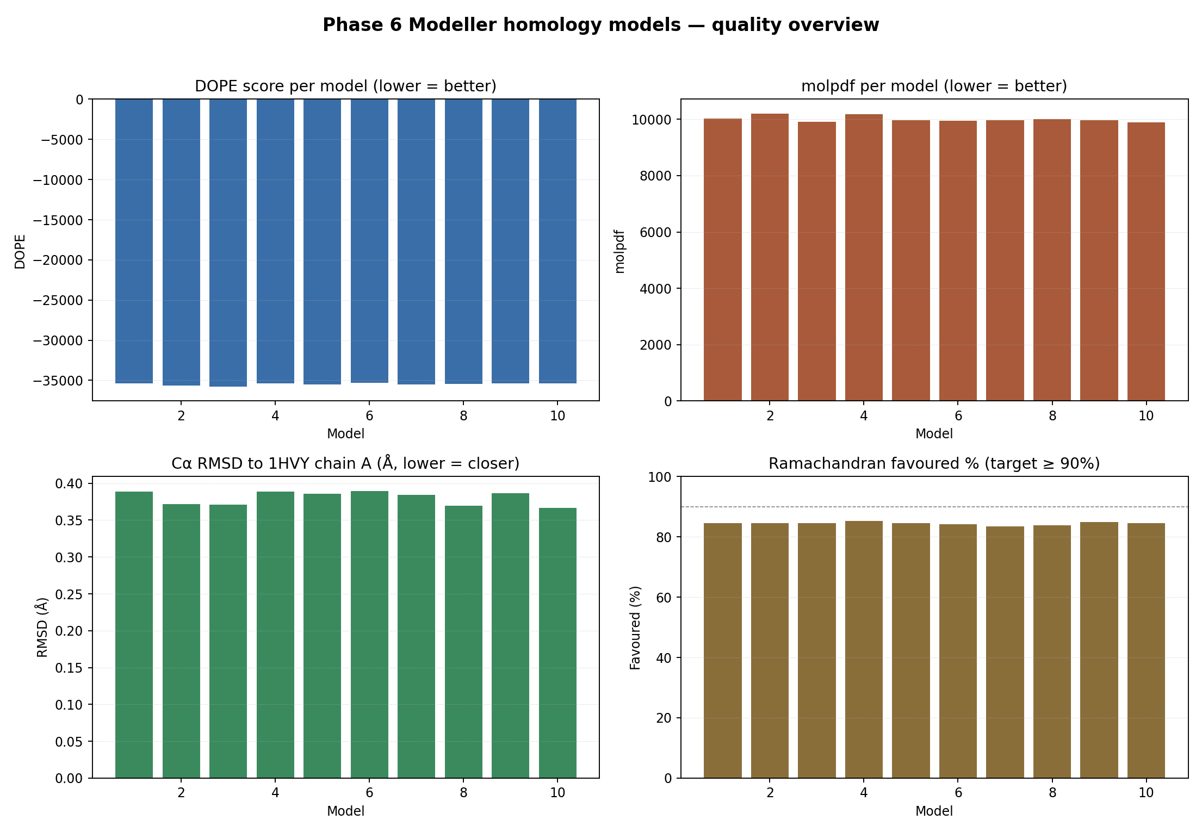

Section 17.6 — All-models overlay (PyMOL)
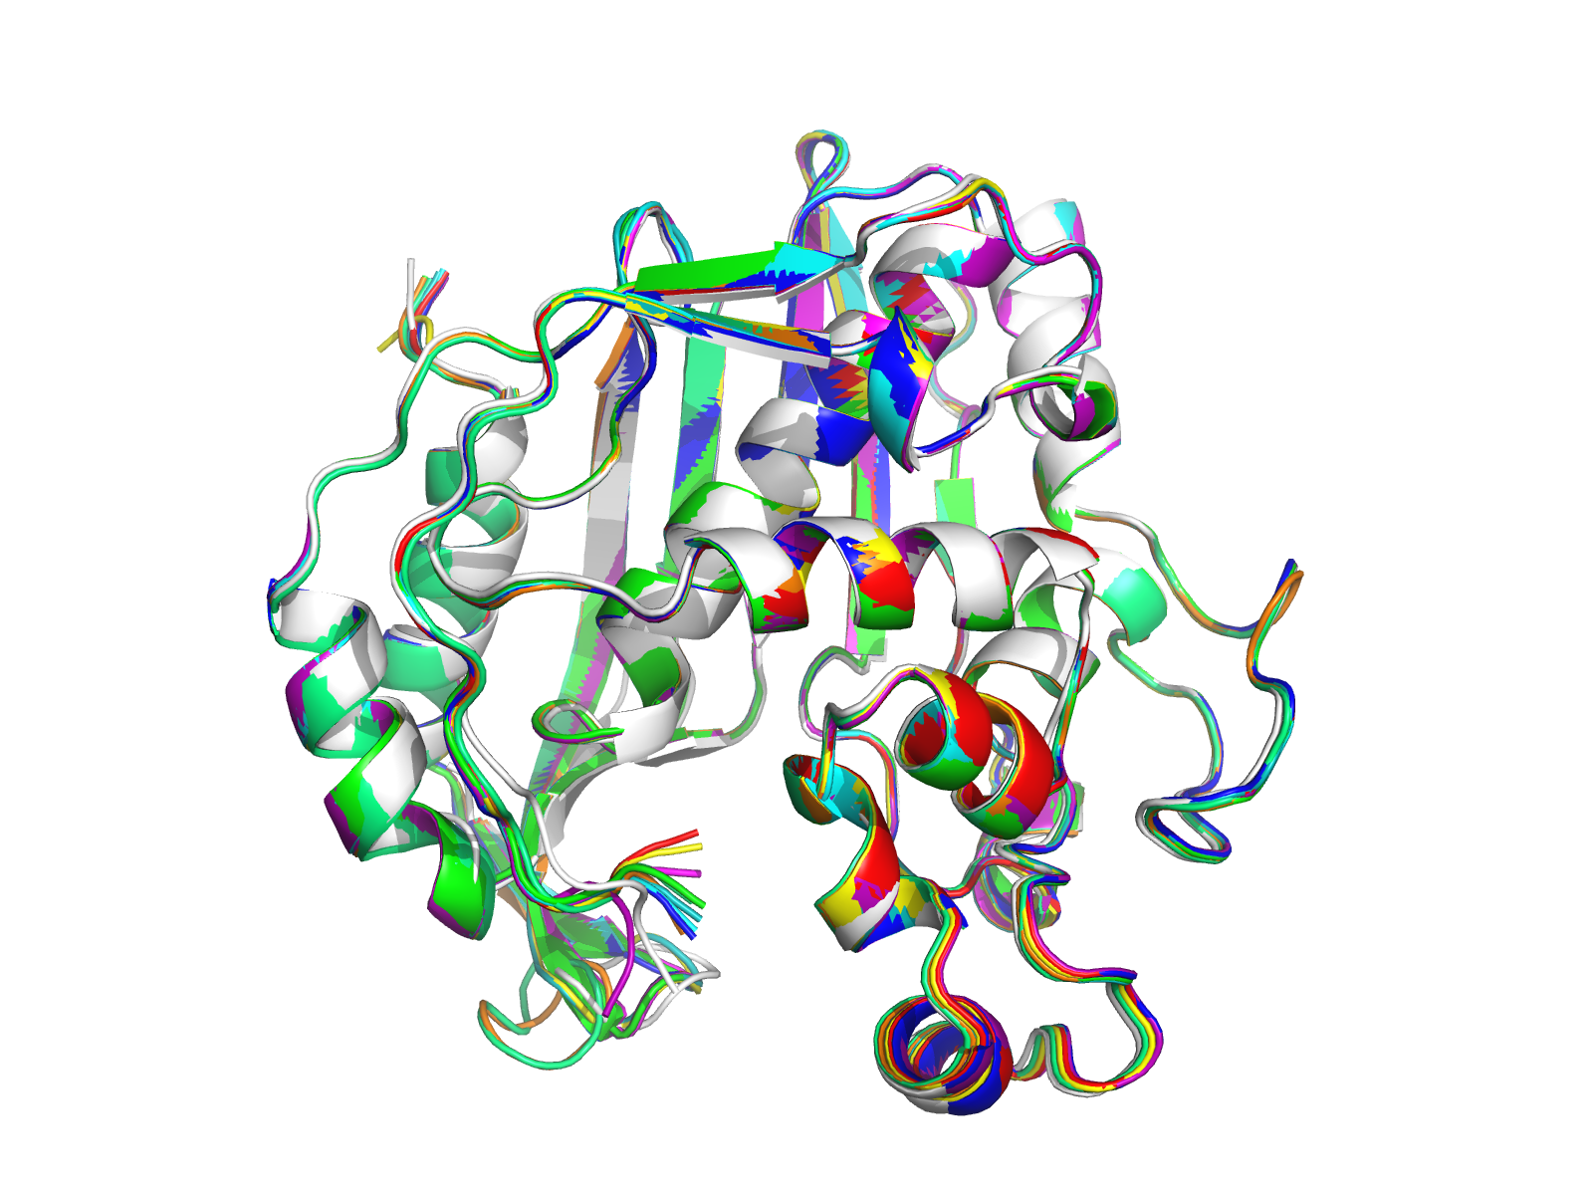

Section 17.7 — Per-model figures

Model 1
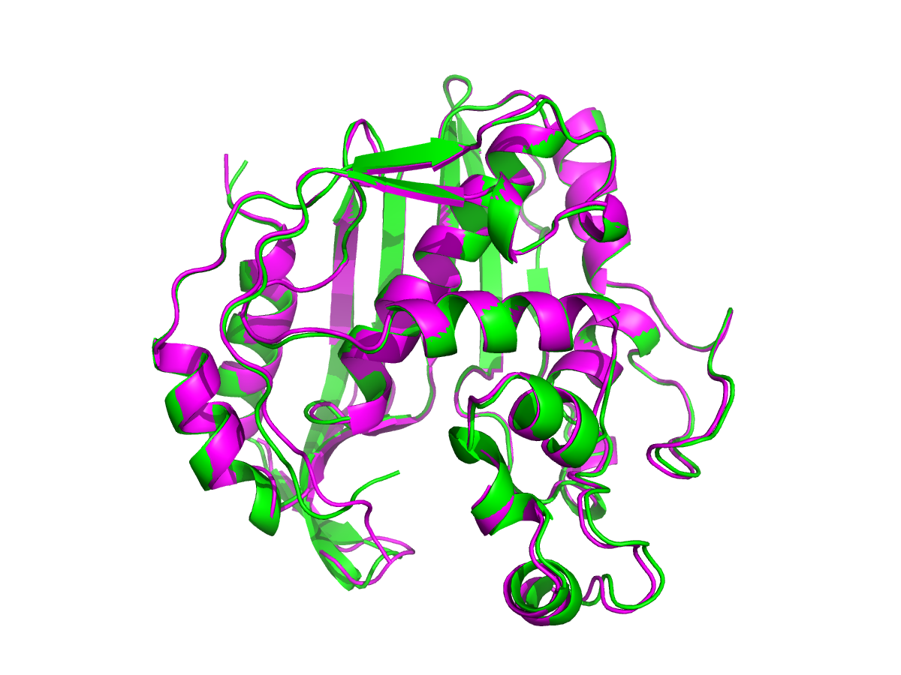
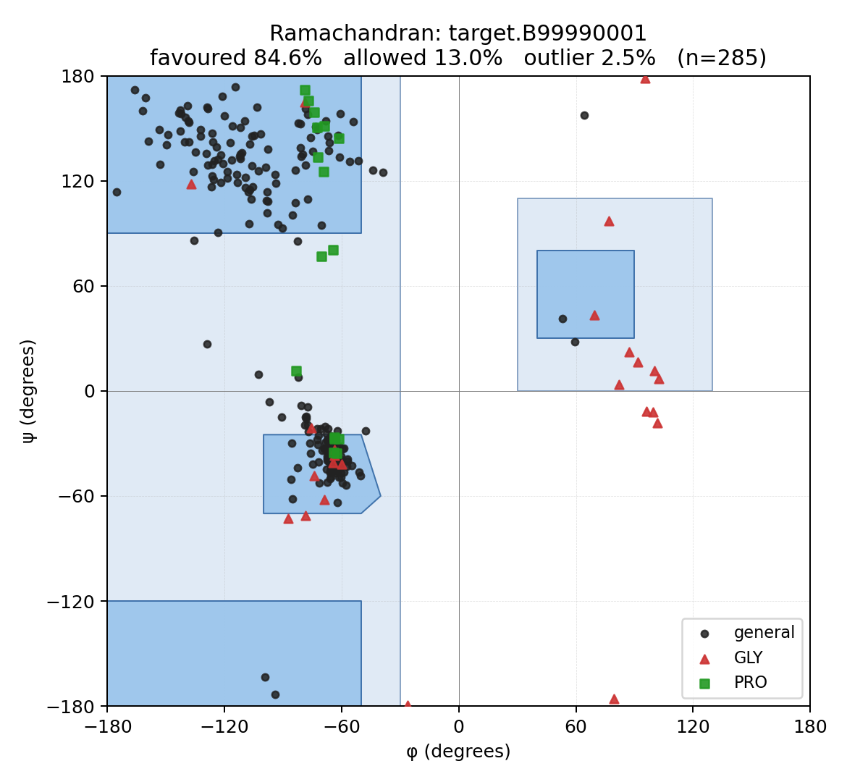
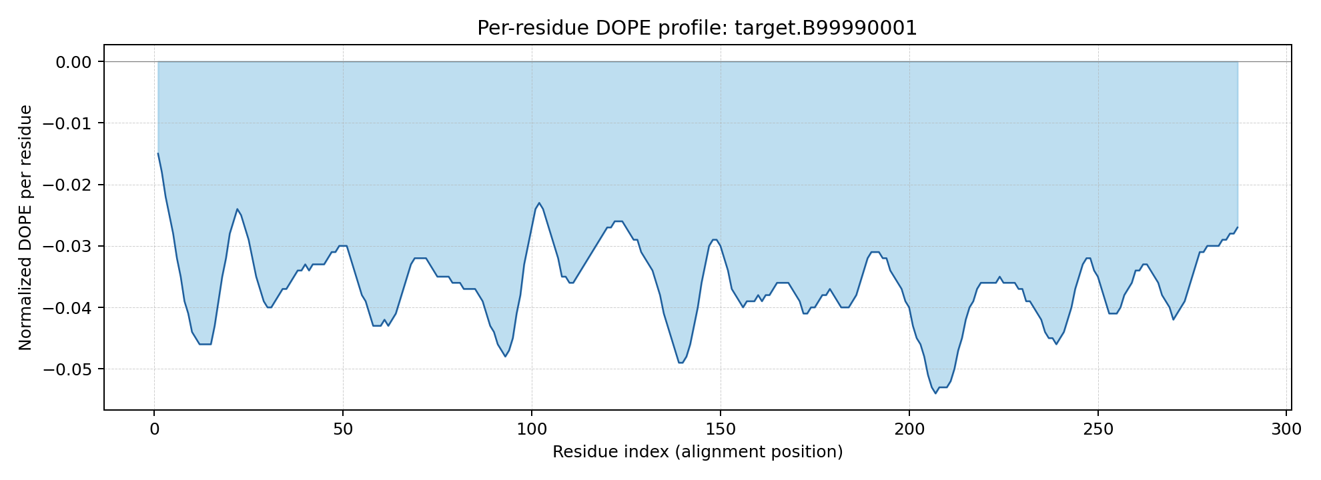

Model 2
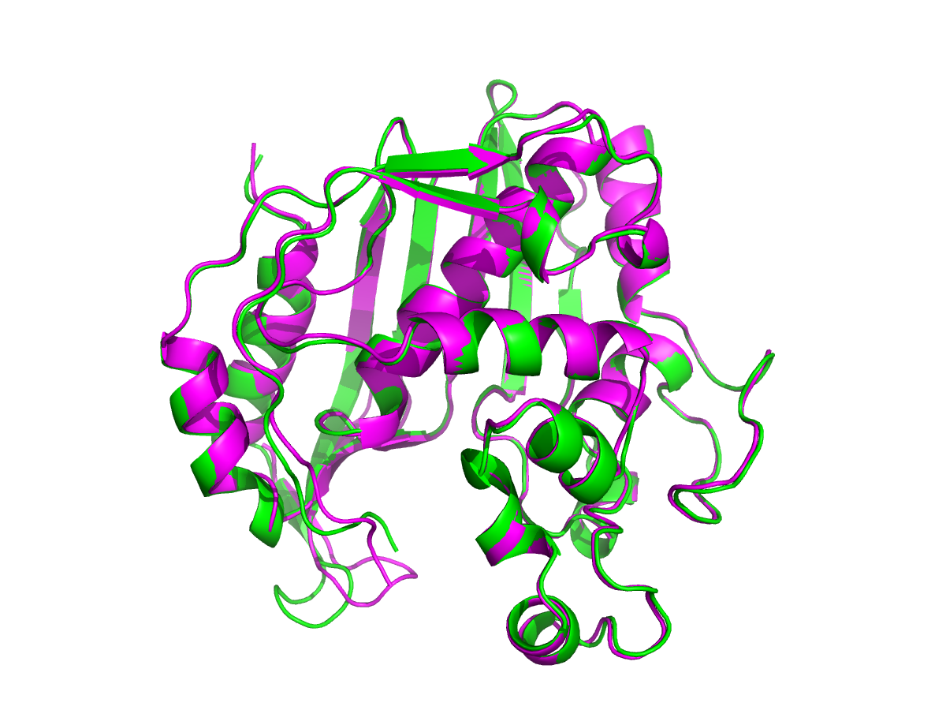
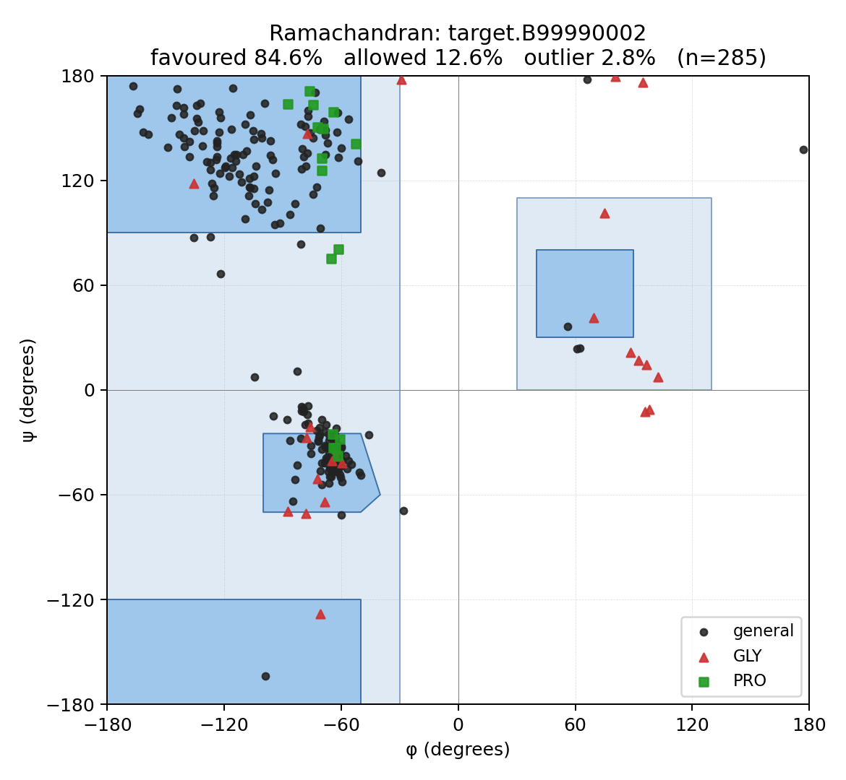
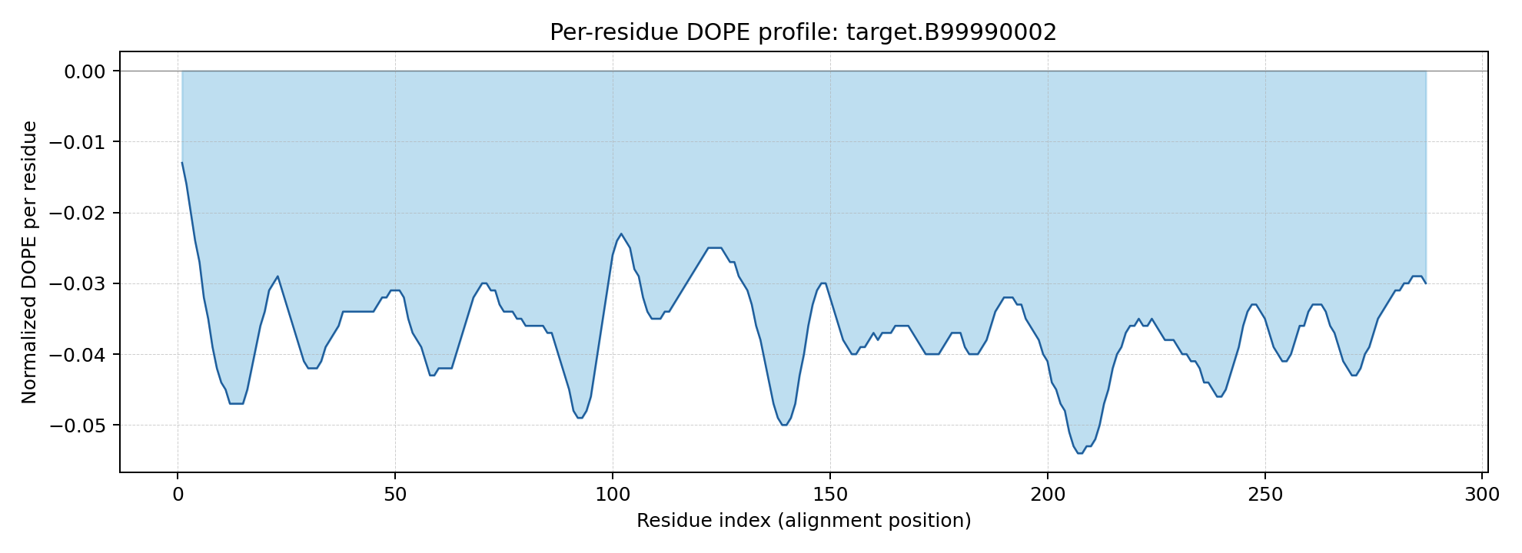

Model 3
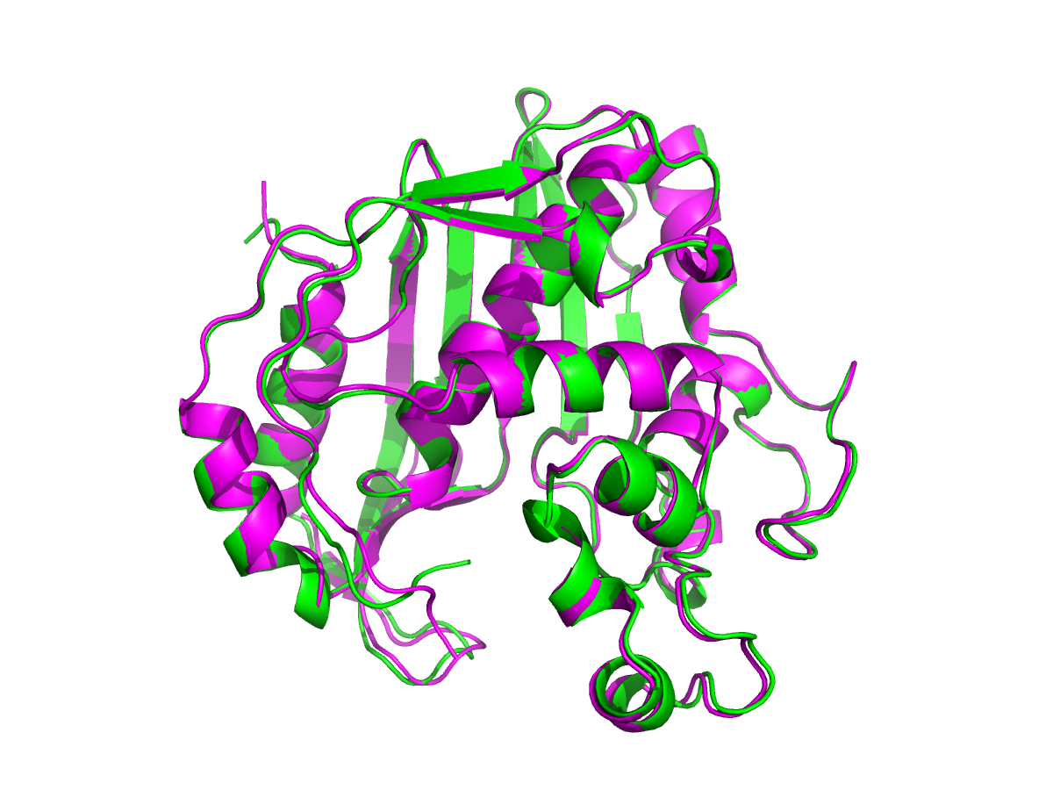
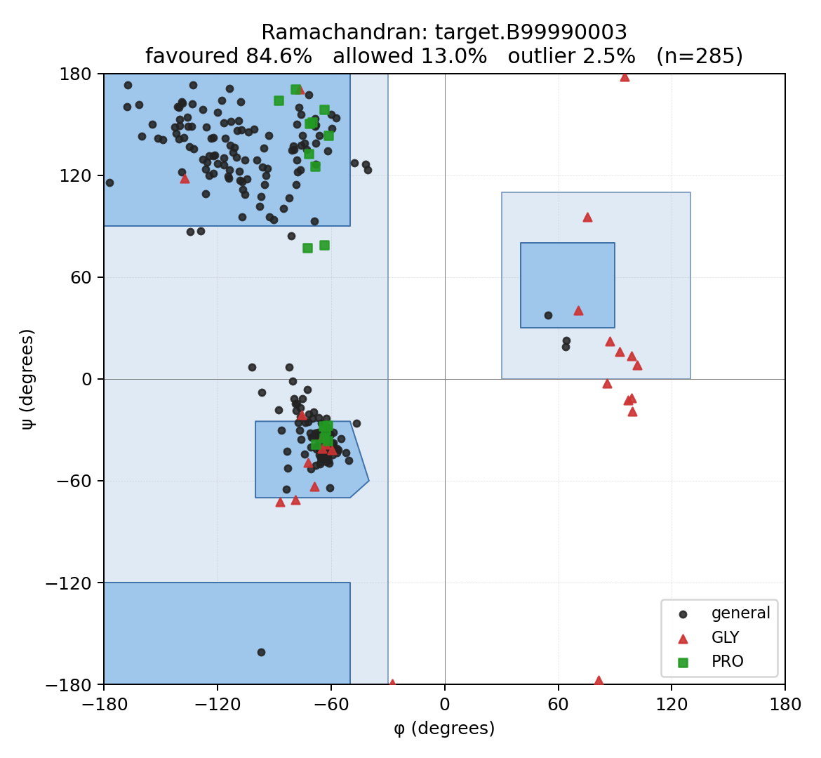
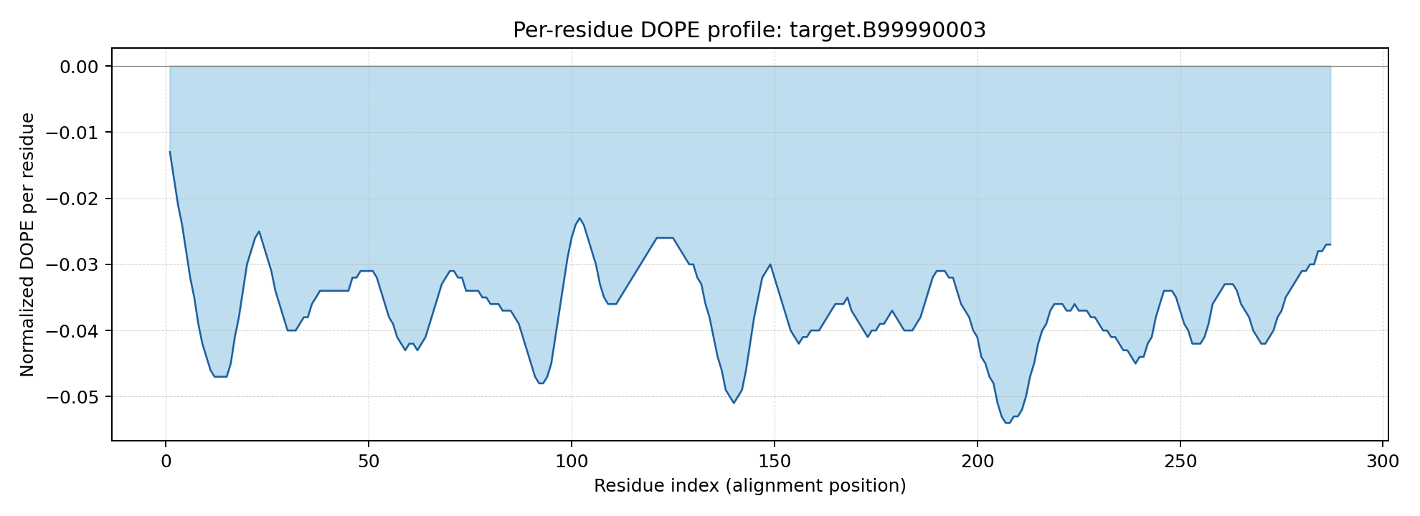

Model 4
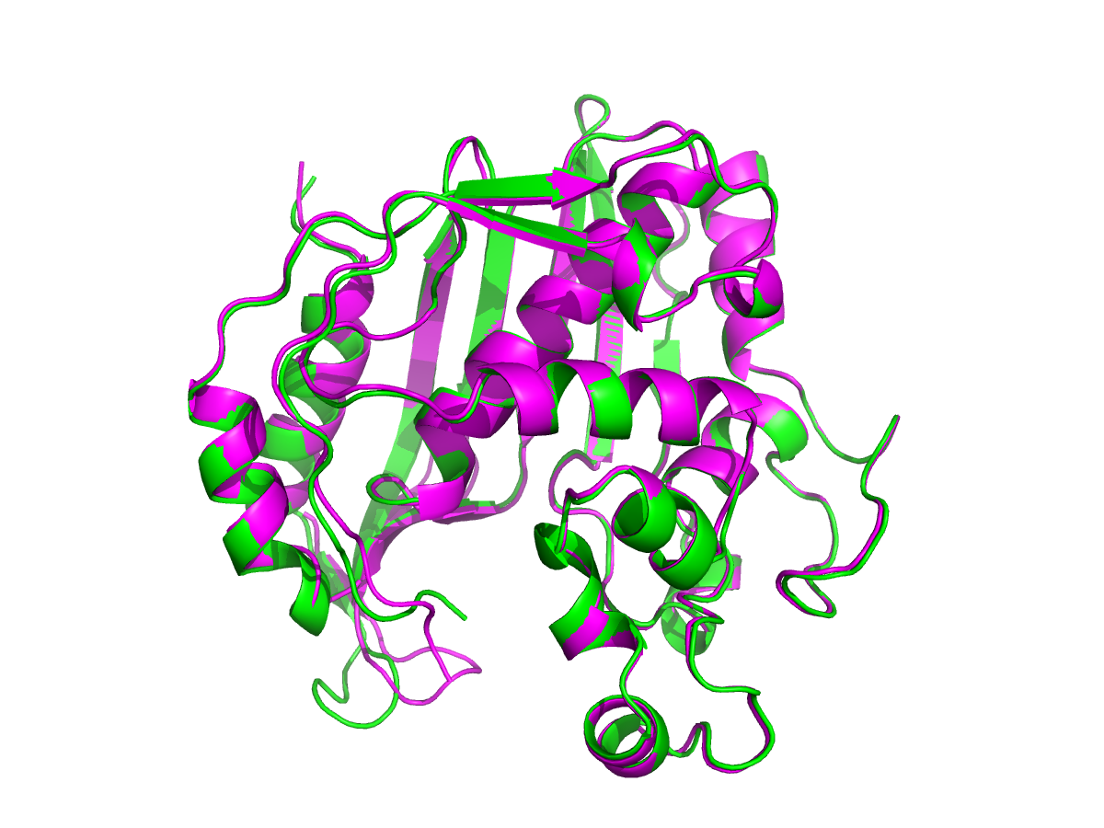
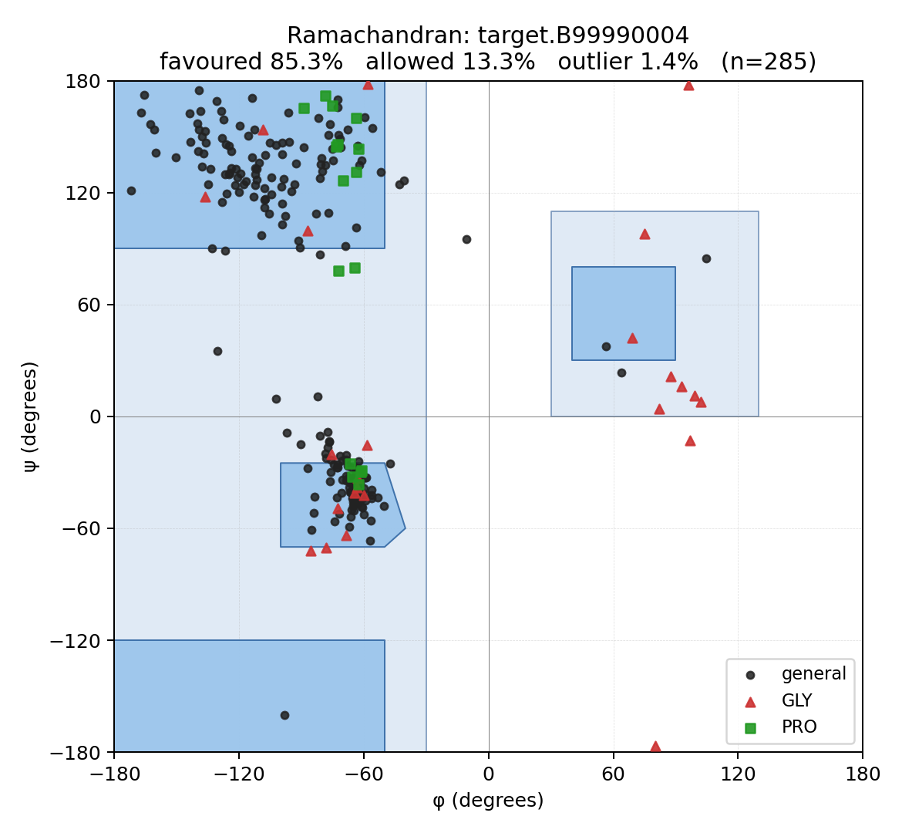
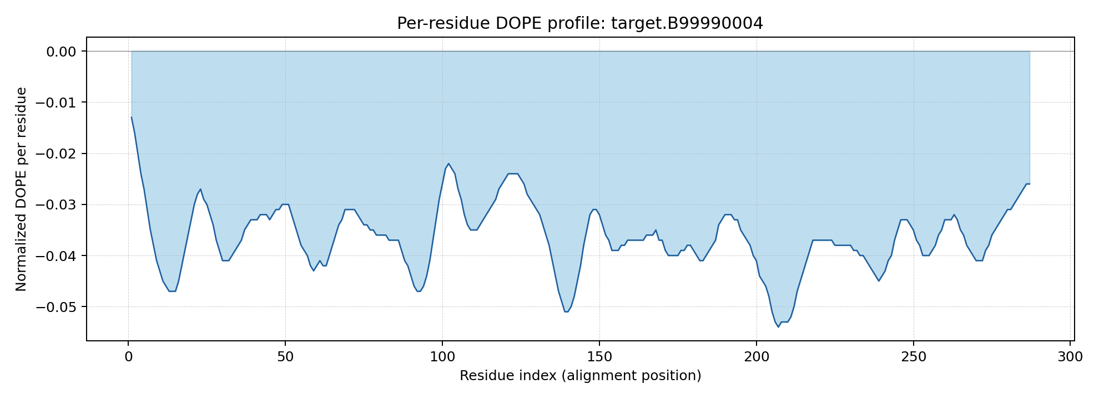

Model 5
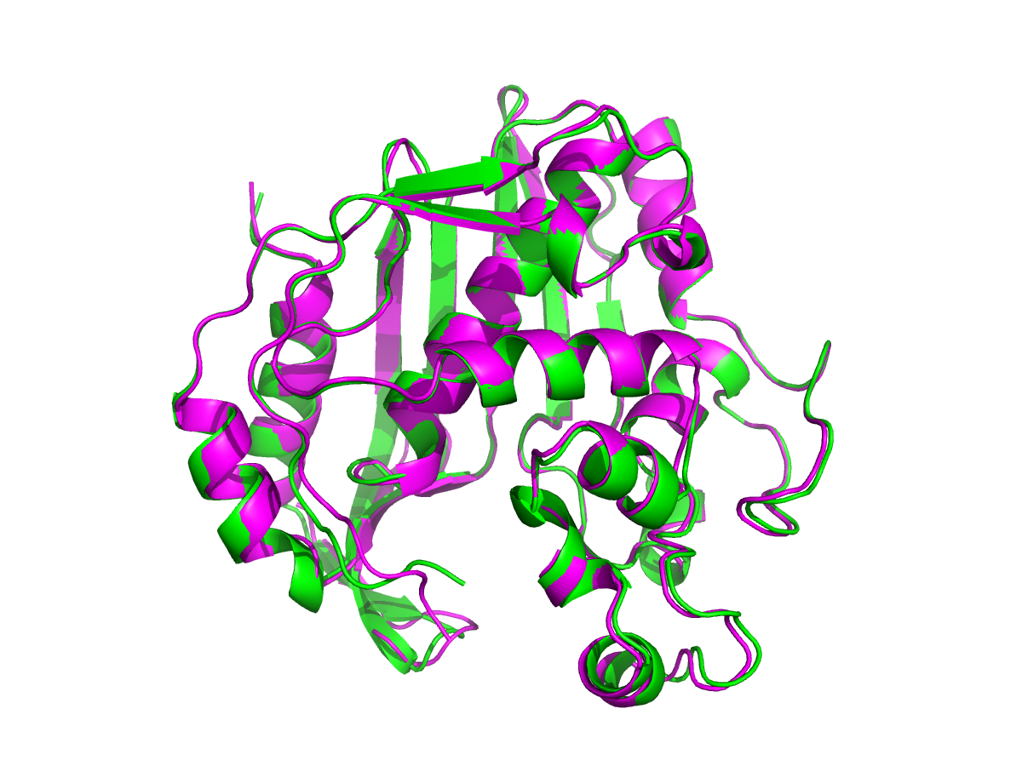
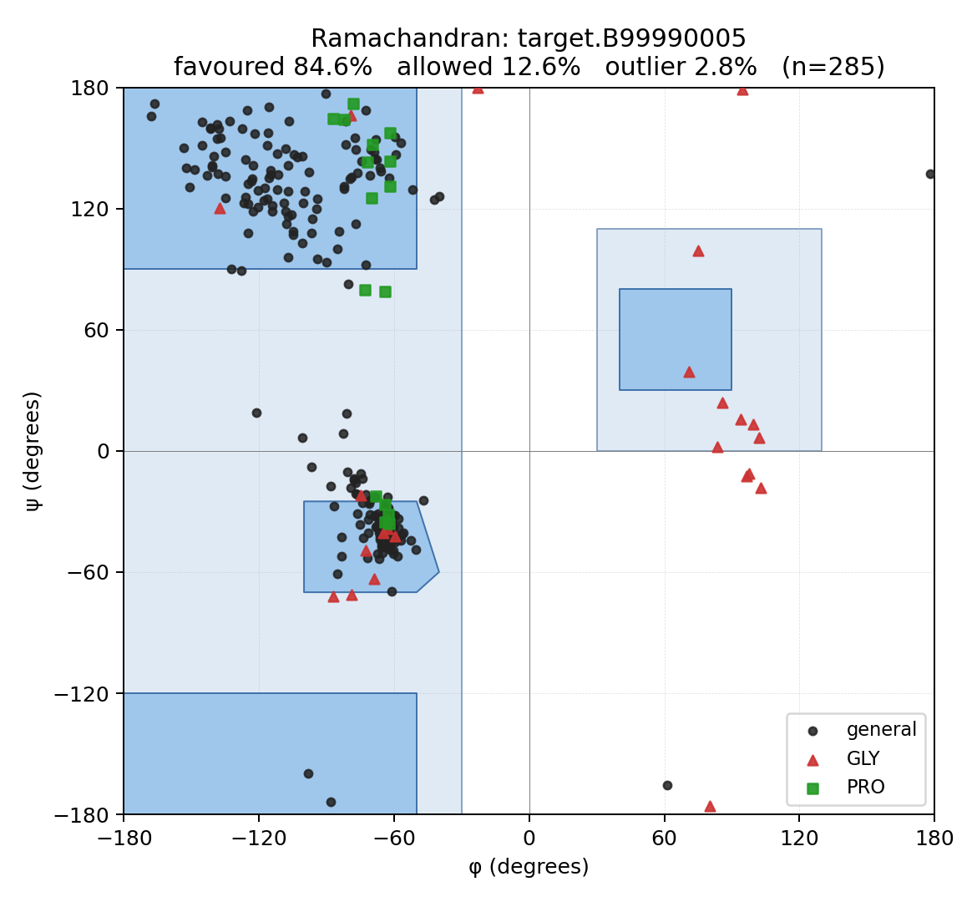
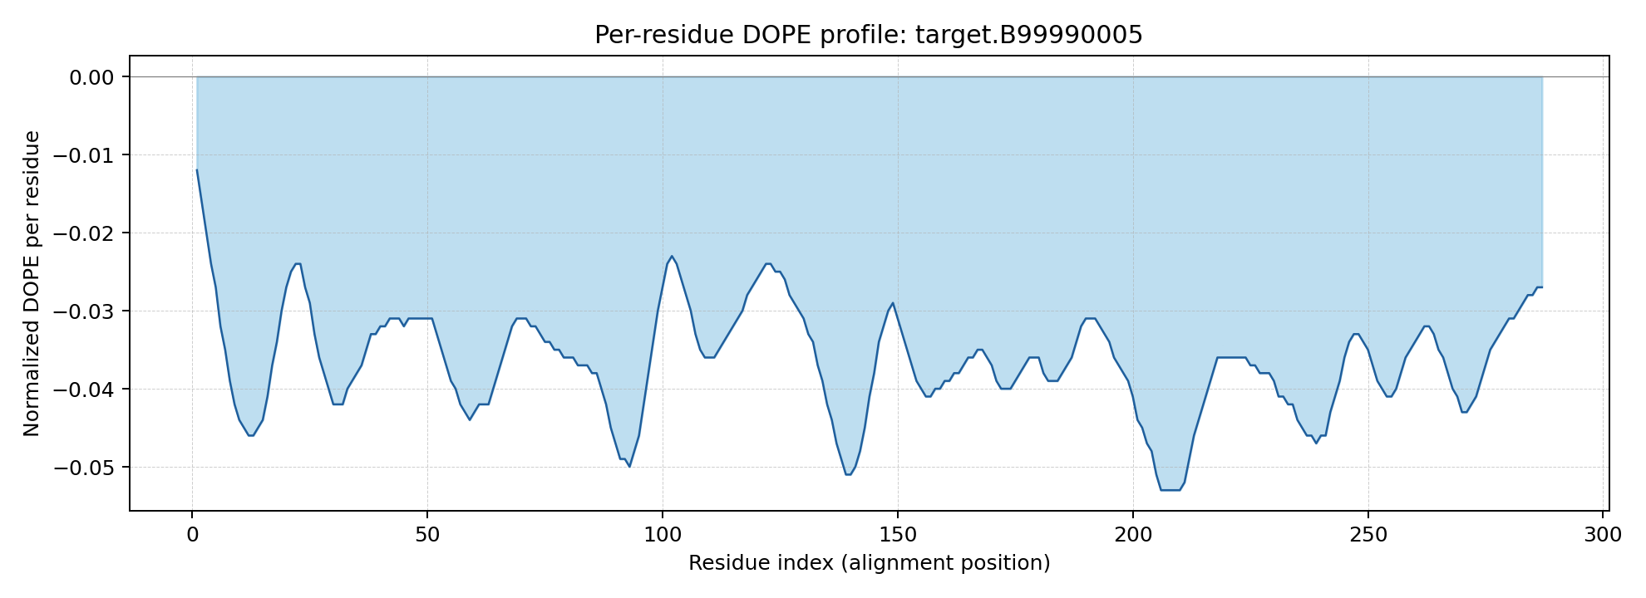

Model 6
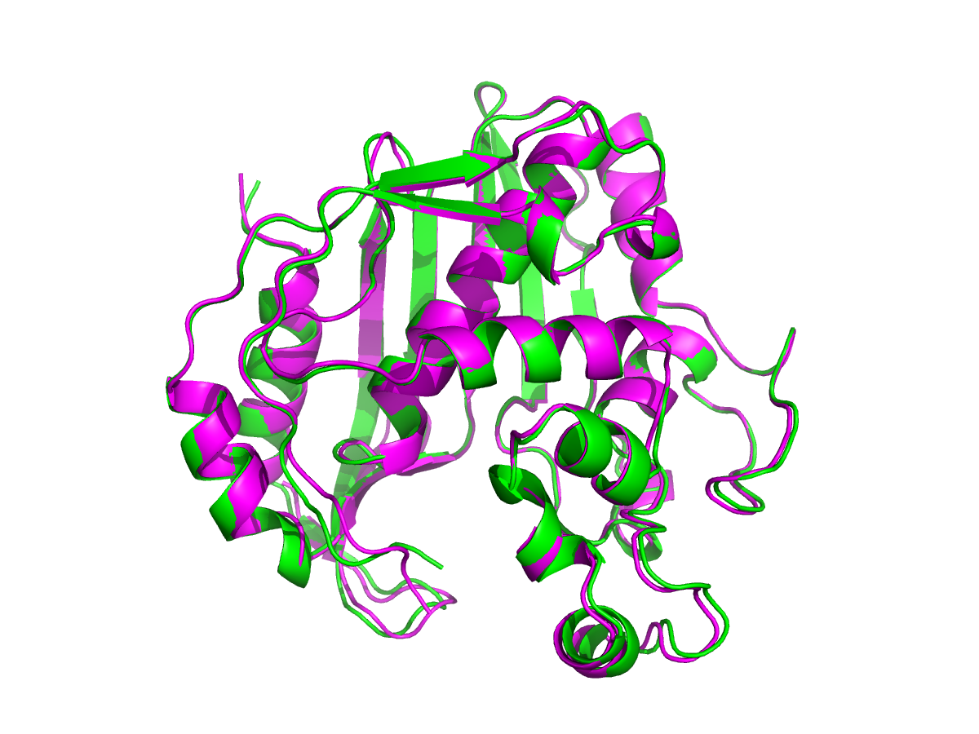
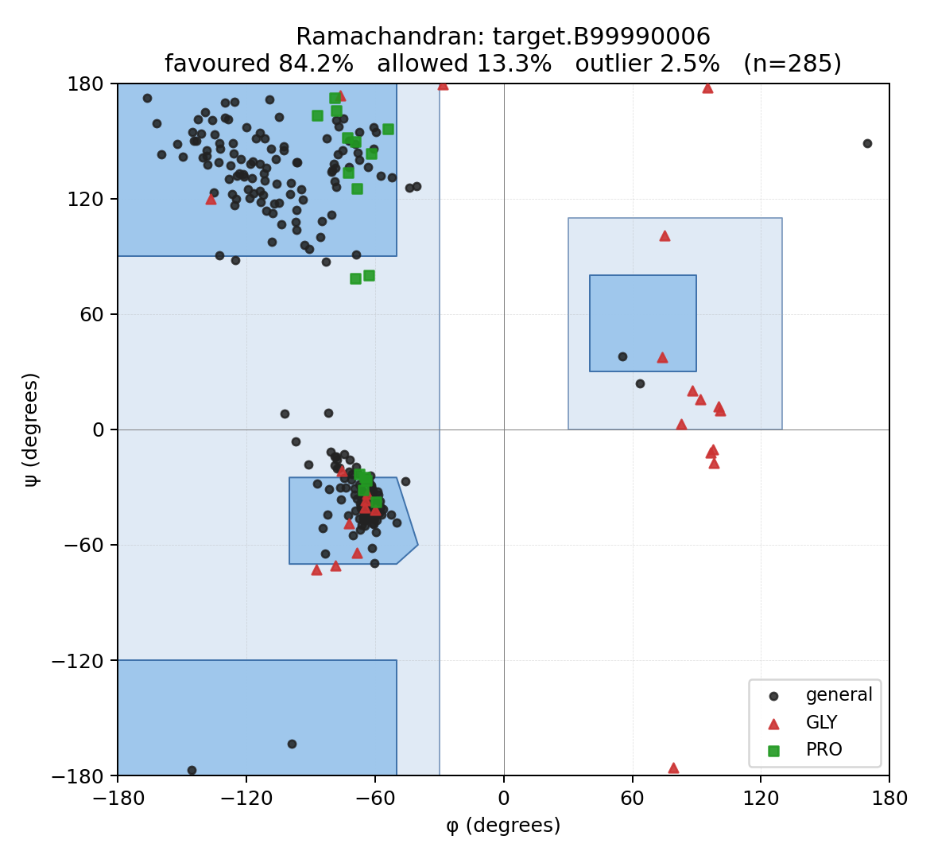
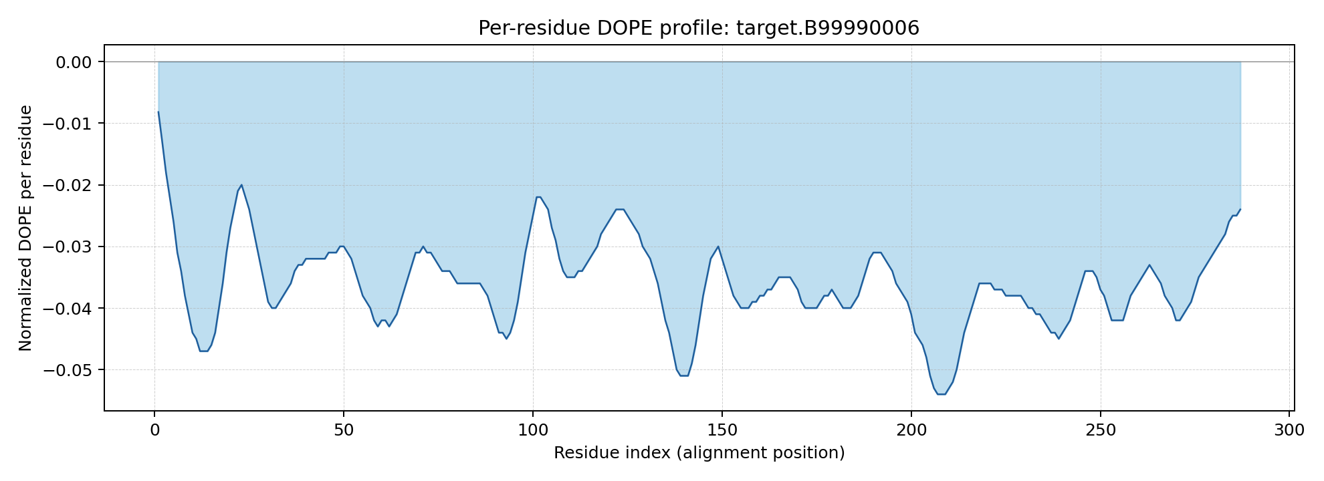

Model 7
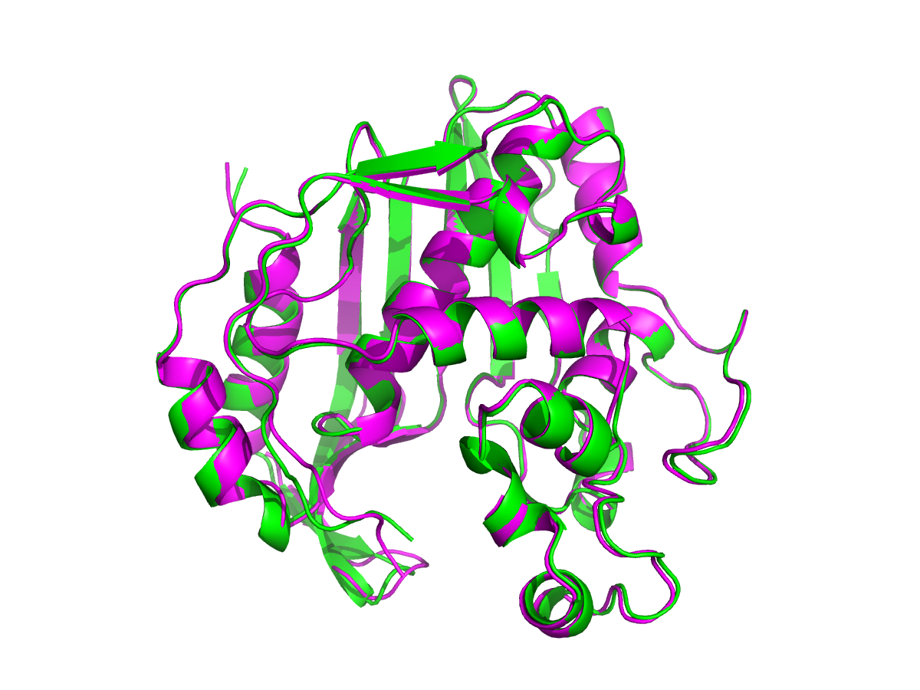
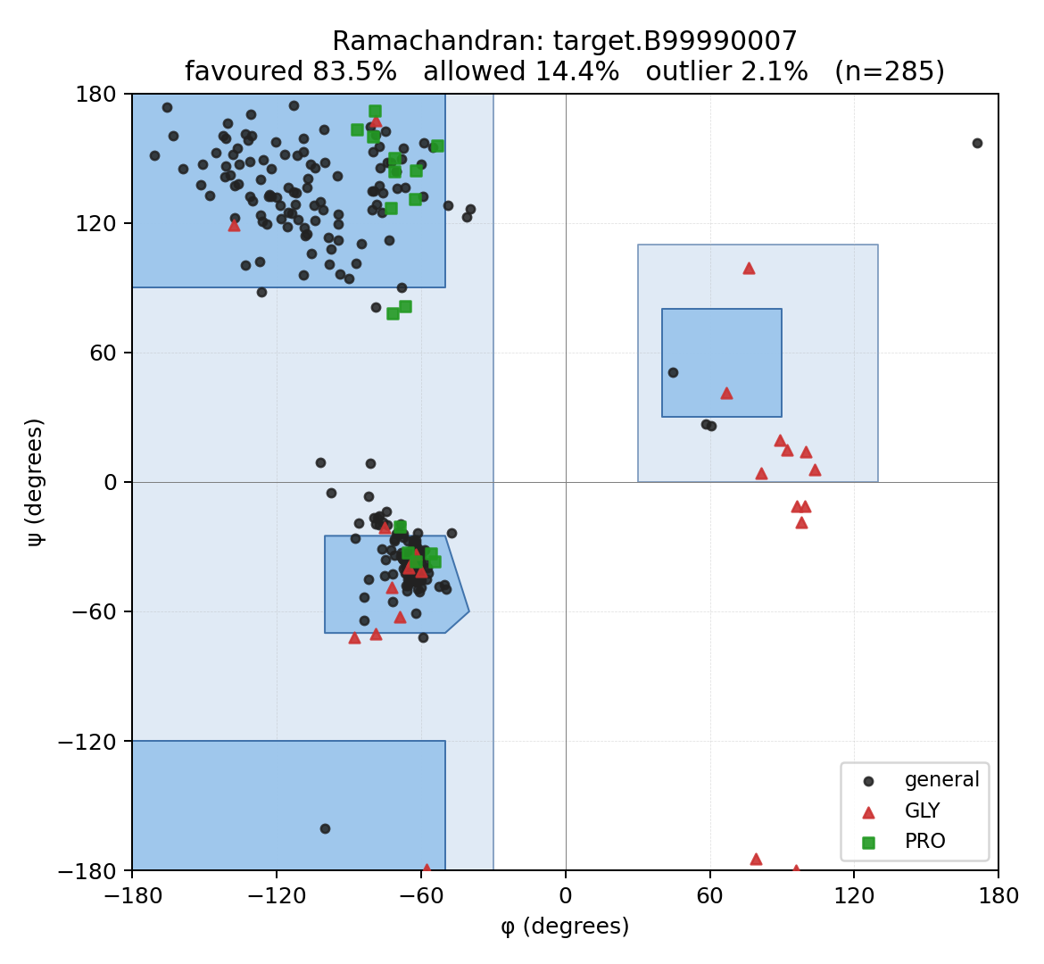
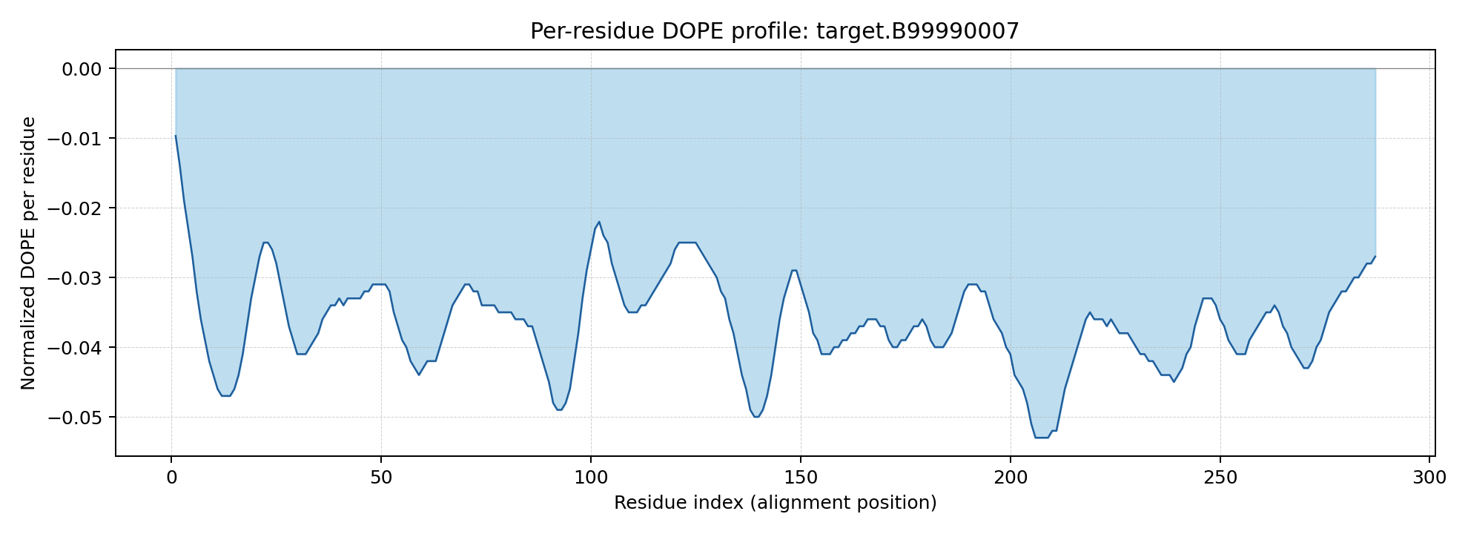

Model 8
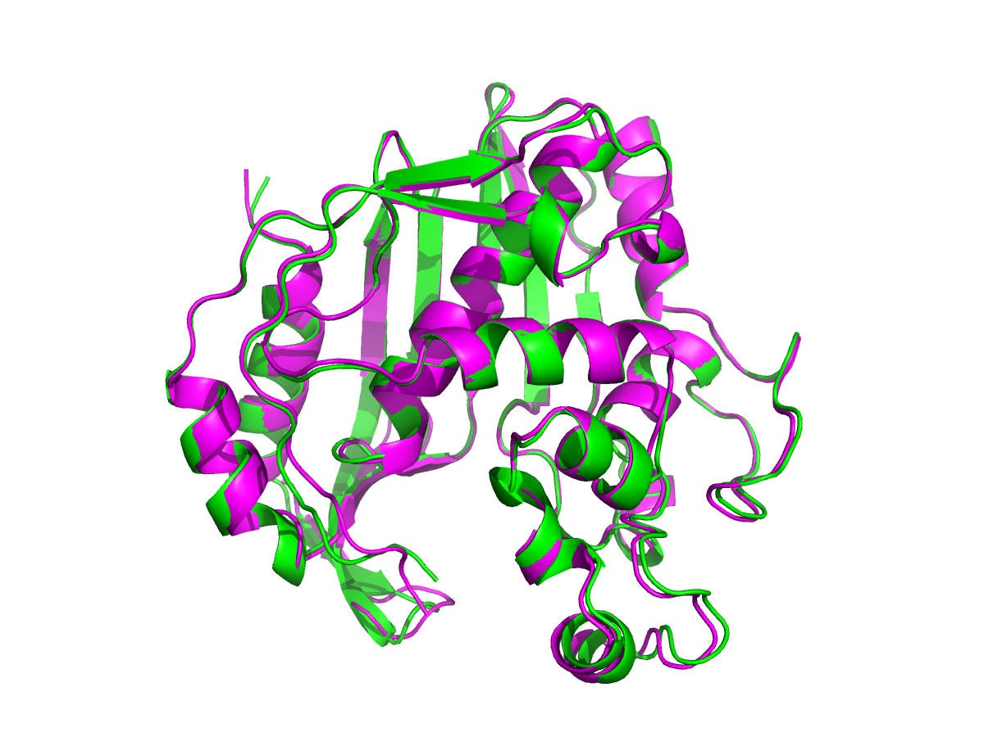
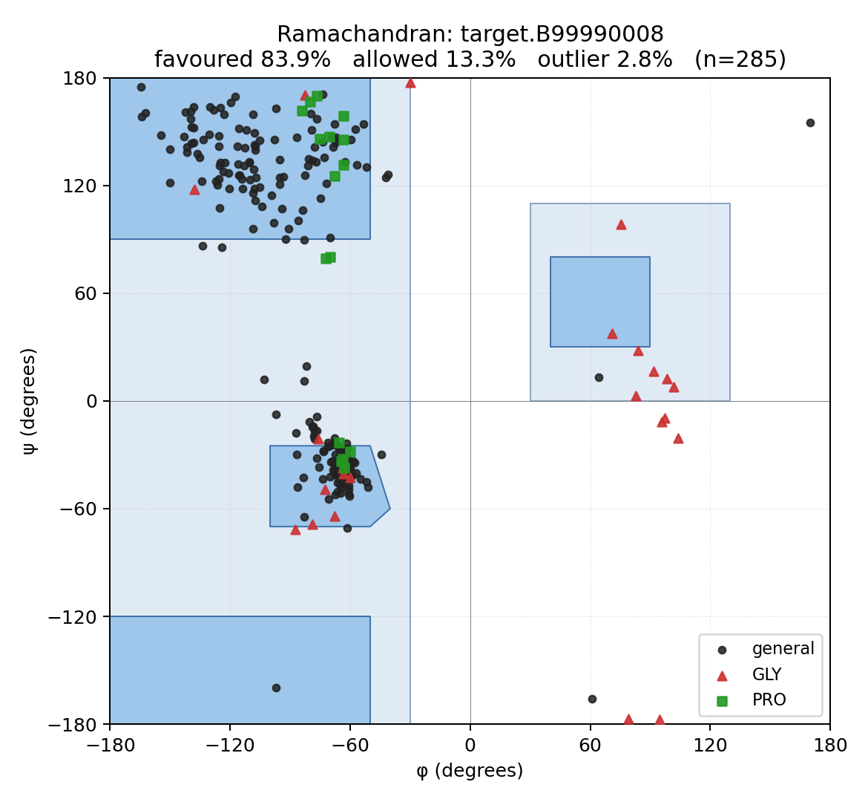
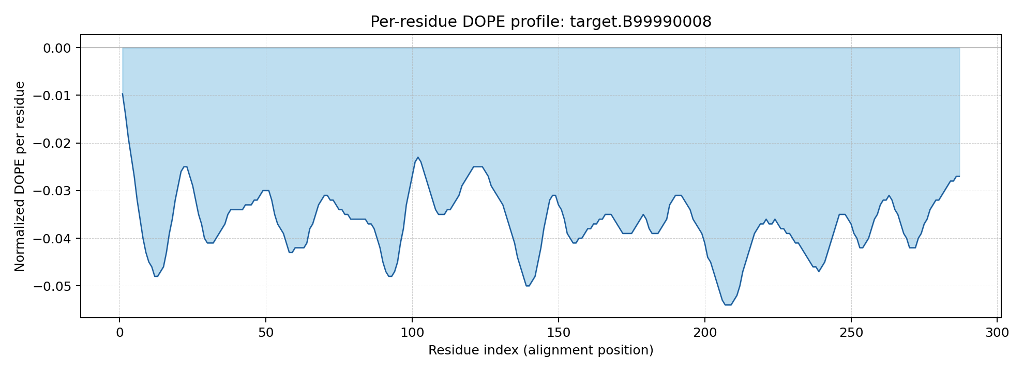

Model 9
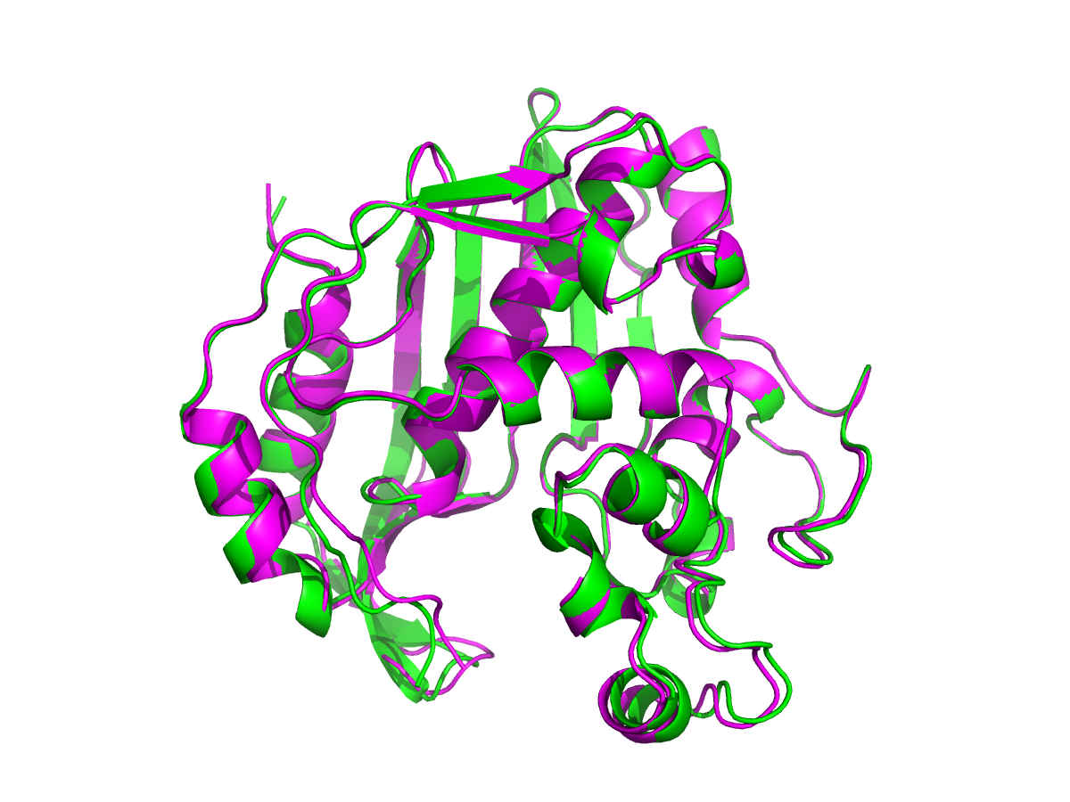
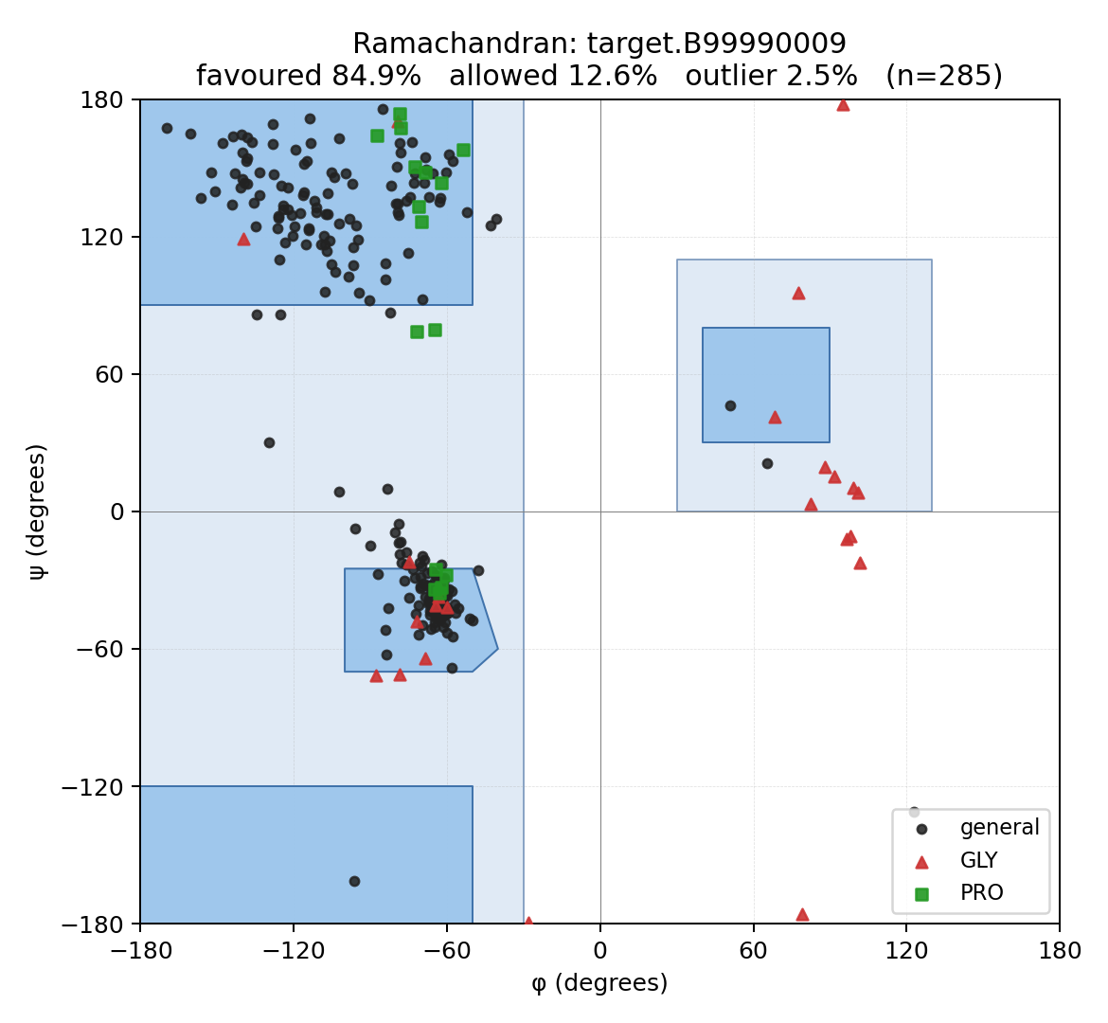
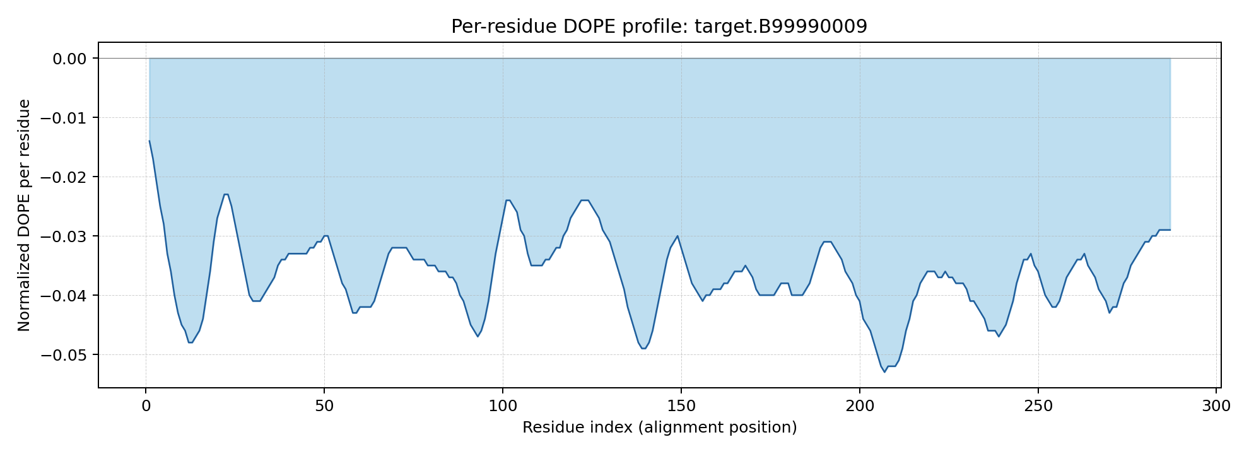

Model 10
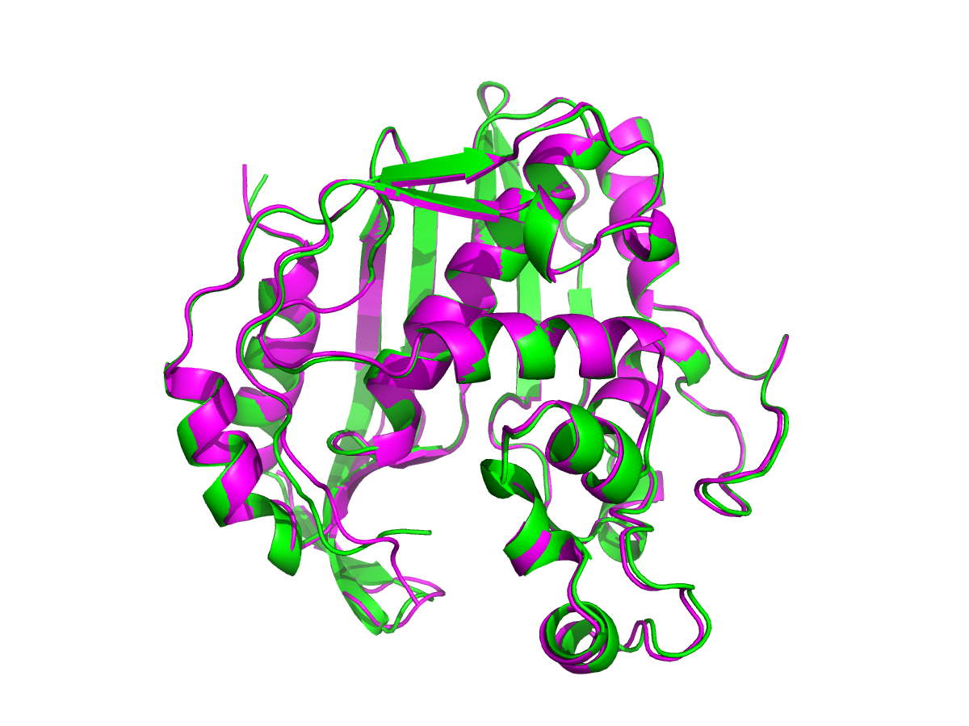
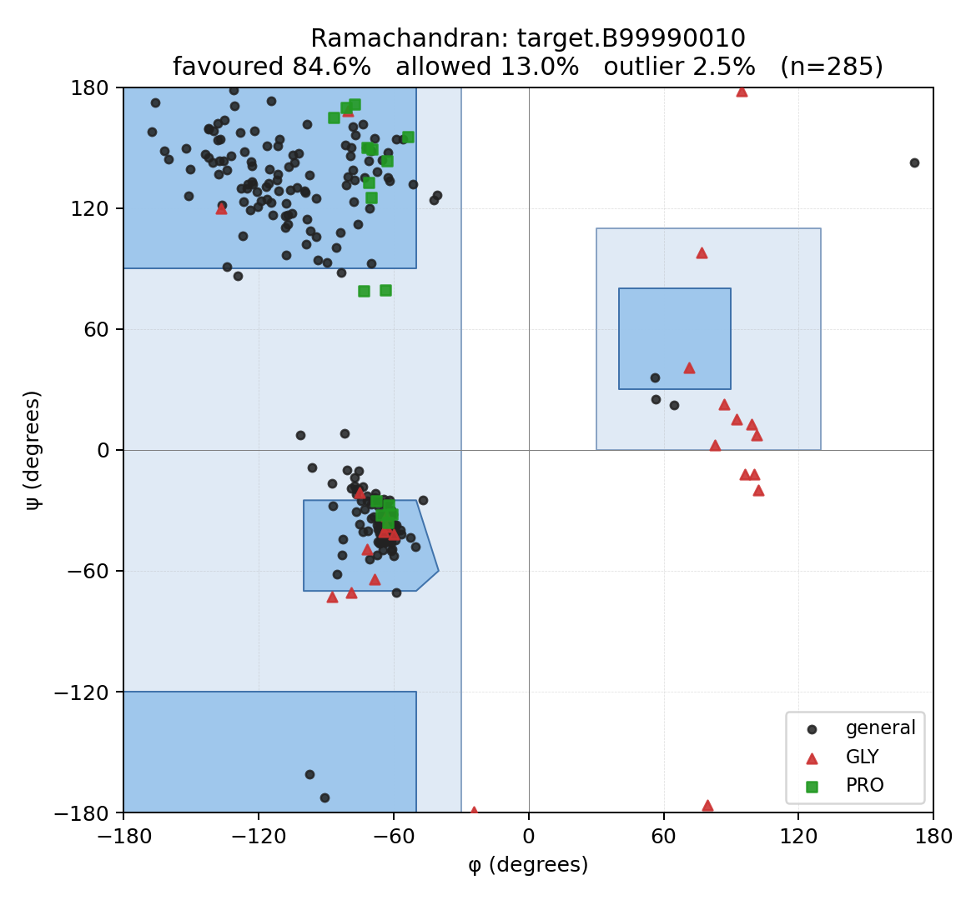
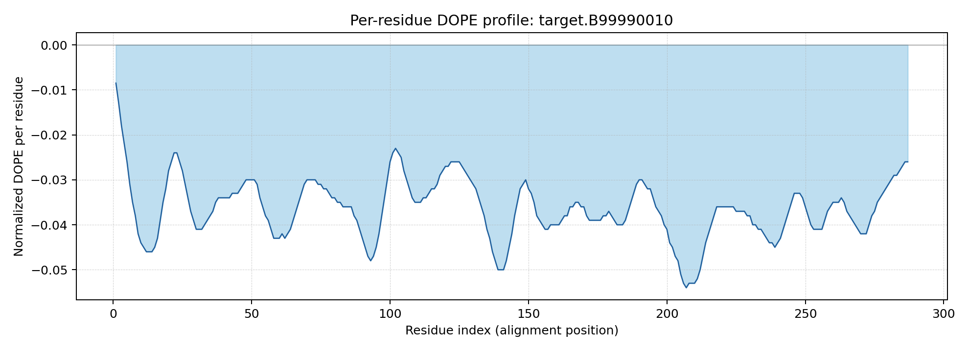

Section 17.8 — Validation note (UCLA SAVES)

For full PROCHECK / ERRAT / VERIFY3D / WHATCHECK validation, upload
`10_modeller/04_modeller_run/models/best_model.pdb` to <https://saves.mbi.ucla.edu/>.

The SAVES web tool has no programmatic API; the upload must be done
manually OR via the project's computer-use channel.

Local Ramachandran (this folder) is the open-source equivalent of
PROCHECK's basic Ramachandran plot — it uses Biopython's φ/ψ
computation and a hand-drawn favoured/allowed-region overlay.

Steps (manual):
1. Visit https://saves.mbi.ucla.edu/.
2. Upload `best_model.pdb` (≈ a few hundred KB).
3. Choose 'Run all programs' and submit.
4. Download the PROCHECK Ramachandran PDF and ERRAT/VERIFY3D HTMLs;
place into this folder.

Section 17.9 — Limitations
All 10 models are extremely similar (Cα RMSD differences < 0.05 Å). Only chain A was modelled; the dimer interface is not reconstructed. Local Ramachandran is a basic substitute for PROCHECK; the canonical validation workflow uses UCLA SAVES (PROCHECK / ERRAT / VERIFY3D / WHATCHECK) which has no programmatic API and must be run manually.

